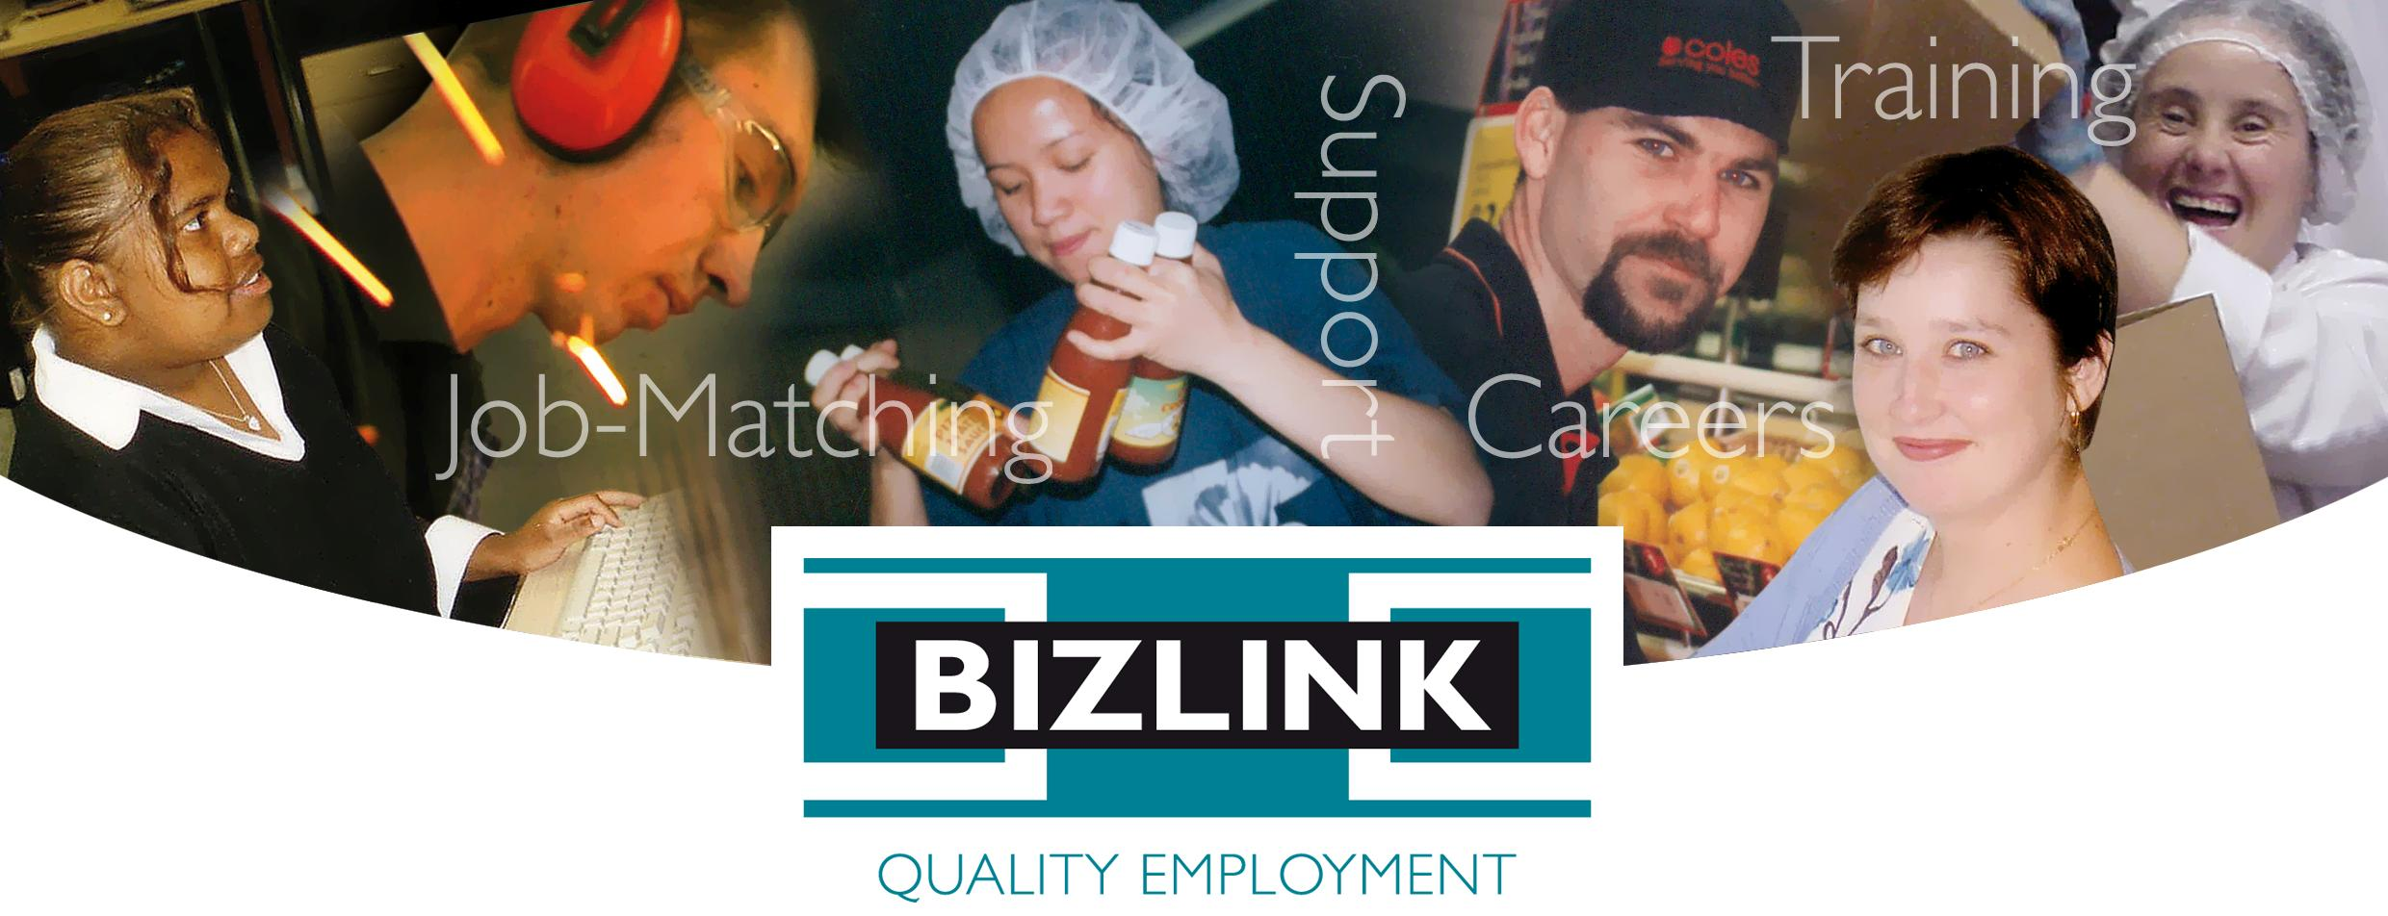

ANNUAL CLIENT SURVEY

REPORT 2021

Prepared by Tara Doyle, Quality Manager
April 2022
Classification: Public, personal information deidentified

Job-matching | Training | Support | Careers

www.bizlink.asn.au

1300 780 789

PURPOSE
This survey is for DES commenced clients who have an email (although those without can still do using the link) we do not include people who have a tag of either: Not for QA as per CATSARI, No Bizzybodies (clients tagged with this, do not want to be on mailing lists), Survey No.
At 21 February 2022, 969 emails were sent and the survey closed 8/03/2022. 86 did not have an email address. The survey was promoted via Facebook. There were posters in the offices with a QR Code for easy access. 79 (8%) surveys were returned. The square root of 969 (number of surveys sent) is 31, so the sample of 79 is a good return rate. The returned surveys supply the information used for this report.
Clients had a choice to complete the survey online, to receive a hard copy and post back or to do over the phone. Of the 79 respondents, 1 completed the survey online (via the weblink promoted on Facebook, office poster and via Coordinators), 78 used the email link.

CONFIDENTIALITY
Comments have been deidentified to maintain confidentiality. For instance, staff names changed to “Coordinator” or “Manager”, client names changed to “Client”, employers names changed to “Employer”, co-workers names changed to “Co-worker” and so on.

QUESTION RESPONSES

Q1. Your details (this question is optional but is needed for any follow up)
Answer Choices | Responses
Your Name | 99% | 73
How long have you been with BIZLINK? | 97% | 72
Preferred Contact Details (mob/email) | 96% | 71
Can BIZLINK contact you to discuss your survey? (yes/no) | 99% | 73
 | Answered | 74
 | Skipped | 5

Q2. How Satisfied are you with your Job Plan?
Every client should have a current Job Plan (not more than 3 months old if looking for work and not more than 6 months old if working). Your Job Plan should be reviewed with you and include your career goals. My Job Plan:
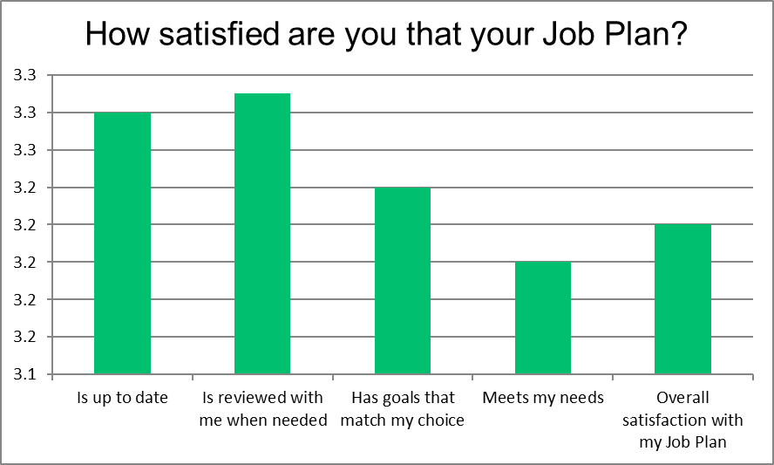
Weighted Average with 5 being the highest score possible
Comments:
- Both JSC & SC have done me extremely well.
- I'm partial paraplegic going through rehabilitation. I need totally retraining for something I can do from my wheelchair but being made to go for a marketing job I'm not qualified for or going door to door sales is inappropriate and stupid.
- I got my own job.
- Haven't even made an appointment for myself to find. A job so can't say I either satisfied/or dissatisfied.
- "SC from Bizlink communicates all Job Plan requirements and goes thoroughly with me. SC is always on time and provides me with a copy of the Job Plan."
- No nothing
- So glad I've found a place where there a no lies and they work with me and not against me!
- SC is amazing! I love every visit I have with her. Her on going support is above and beyond.
- It is just emailed to me without any consultation.
- Staff are amazing
- EC goes above and beyond to help me with anything I need and is also my own little cheer squad that doesn't let me give up.
- "nothing was done I never got a job my guy JSC barely spoke to me communication was shit at best i am in the process of leaving"
- I really like working for Bizlink
- They try to find me local jobs that I'm interested in
- Blessed with a great team

Q3. Has a Job Search Coordinator provided help to find a job over the past 12 months?:
This is a navigation question i.e. directs respondent to appropriate section of survey dependent on response.
Answer Choices | Responses
Yes - answer the job search questions | 62% | 48
No - I have worked for last 12 months - go to next section | 38% | 29
 | Answered | 77
 | Skipped | 2

Q4. How satisfied are you with the help from your Coordinator to find a job?
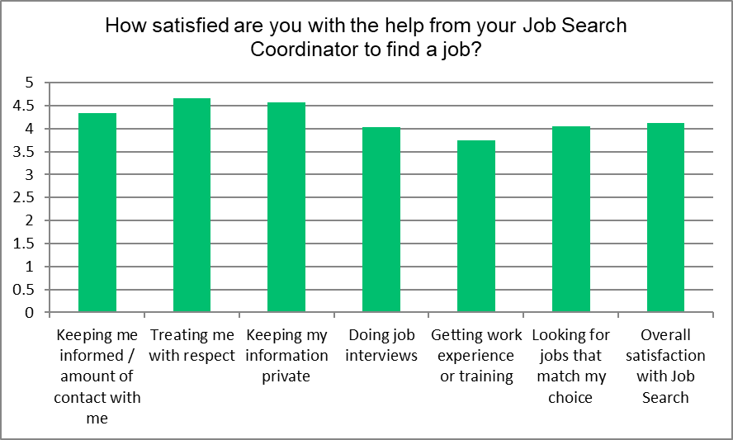
Weighted Average with 5 being the highest score possible
Comments:
- SC has been fantastic in helping me find a new job which suits me. She has been an amazing source of support and encouragement to me and "understood me". I will miss not being with her. I liked her very much.
- Awesome bunch of people!
- I have not needed job finding support for more than 12 months
- I have ongoing health issues which have been discussed with my job search provider.
- I have had to look after my husband since he had foot surgery last year and he is still recovering.
- Please call me on this one.
- Staff are amazing
- the staff at bizlink give the most respect with my cleaning job
- It would be helpful to be put forth with a meeting with a job that I am qualified for. As I can apply for it, but don’t always know how to answer the way I should. But I do really well in interviews..

Q5. Are you currently working?
This is a navigation question i.e. directs respondent to appropriate section of survey dependent on response.
Answer Choices | Responses
Yes - answer work-related questions | 43% | 20
No - but I have worked over the past 12 months and want to answer the work-related questions | 6% | 3
No - skip to next section | 51% | 24
Any comments |  | 0
 | Answered | 47
 | Skipped | 32

Q6. When thinking about your current job:
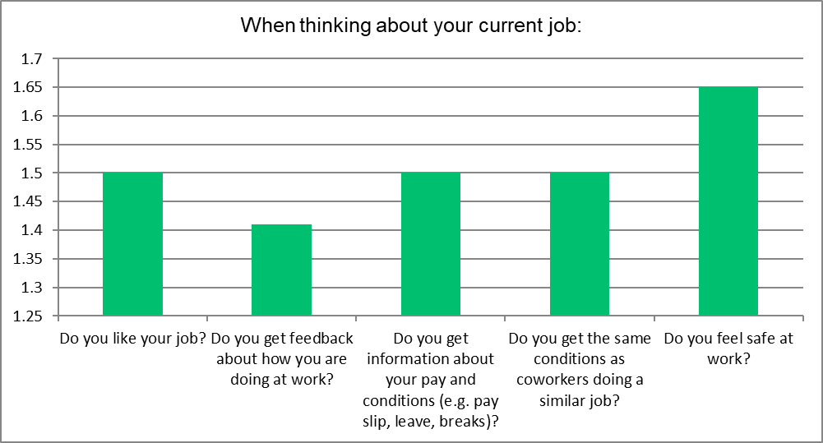
Weighted Average with 2 being the highest score possible
Comments:
- I do not have any problems
- My bizlink contact is currently helping me navigate better working environments
- This is only my second week in my new job so I am still not sure about pay slips etc.
- covid is a concern at work
- Have not had an appointment yet.
- No nothing
- "never got work"
- the staff go through with my pay if I need to be
- The equipment I use is always breaking down

Q7. How satisfied are you with the help from your Coordinator to keep your job?
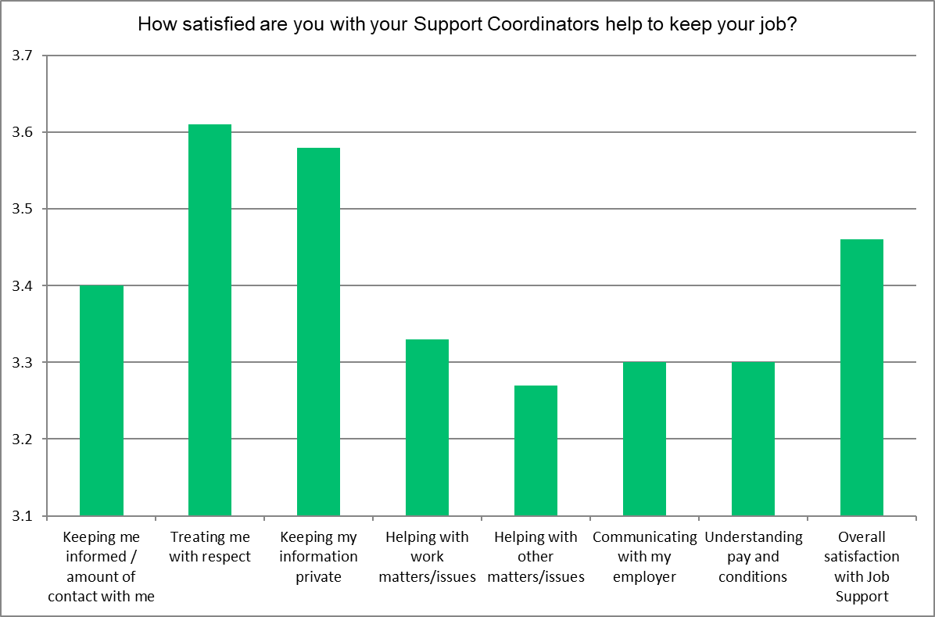
Weighted Average with 4 being the highest score possible
Comments:
- No problems
- I have always had supporting coordinators
- SC has been fantastic in my previous job at the Esplanade Hotel in Fremantle. I have only just begun with TC so I don't know her yet.
- SC maintains a professional standard of always being available to talk to me, remains confidential with my details, provides excellent suggestions, support on any work issues.
- Without Bizlink and SC continued support I would not be mentally able to cope with working. I truly value and appreciate weekly contact with SC at Bizlink.
- SC always helps me if ask her too. But if she can't help she will also tell that's what I like about her.
- It’s great support to be able to chat about work issues with someone not part of work. It gives you a different perspective

Q8. What do you think would happen to your service if you made a complaint?
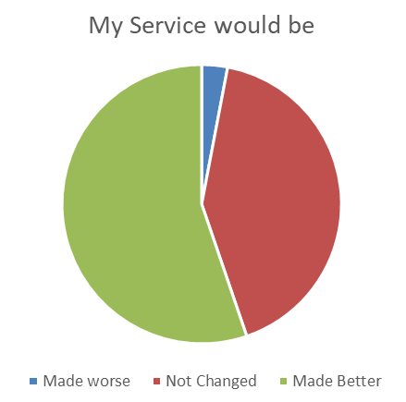
Comments:
- Have not had an appointment
- I have no complaints really we had a issue but we sorted it out together so it all good nothing to worry about.
- Unsure
- I haven't had any complaints with the service provided
- I have a very good consultant who knows that my husband had foot surgery last year and that I was his full time caregiver and could not work.
- Unsure
- Hopefully things would change for the better.
- You can't improve on excellence and Bizlink Cockburn will help with absolutely anything I need, you have employed staff that put other companies to shame so keep doing whatever you do to find them.
- They seem to help me alot
- I would like to think that any compliant that was ever made would not be held against me and that the issue would be looked into and solved
- Everyone there is so sweet and caring, so if I had an issue I know they’d help me sort it out immediately!
- I had made a complaint, I was not put in a very good place. Felt really hurt. I did talk with my job provider and we are okay. But it wasn’t a good experience

Q9. How likely is it that you would recommend BIZLINK to a friend or colleague?
79% of respondents were highly likely to recommend BIZLINK ( a score of 7+).
DETRACTORS (0-6) | PASSIVES (7-8) | PROMOTERS (9-10)
21% / 15 | 14% / 10 | 65% / 46

Q10. What do you like most about BIZLINK?
Comments:
- They are professional and caring.
- The support I get from my coordinator
- It suits my needs and goals
- That 2 out of over 6 of my bizlink coordinator's/ job support have been really good.
- Friendly helpful and supportive
- The staff are genuine
- How caring and understanding they are, you can also tell that they genuinely want the best for you.
- My contact person has been very kind and patient with me while I recover.
- Free alcohol
- continued support
- Friendliness....attentive to individual needs ... always helpful
- Caring out look
- Everyone is friendly and on first name basis welcoming
- staff helpful , meet needs and support
- They listen to my concerns and do everything they can to help make situations better
- They are super friendly and supportive.
- Have not had a appointment
- The location, and the help that I needed that they’re providing.
- Personalised service so that the job provider gets to know me well
- ongoing support AFTER finding job
- Support
- The level of respect that I receive in our dealings.
- "Weekly contact at a time convenient to me. Great suggestions by SC with work issues. Support and understanding that I do a mental disorder, however, I am respected completely."
- Just say SC see if had then called instead that's what about that always you what they are doing?
- The very kind staff
- Unsure
- I like bizlink because is very flexible, understanding and helpful.
- The connection with the support team. They listen and they have always been proactive about my situation.
- There understanding of me.
- Team at midland are proactive and have helped me with any issue I have had
- Flexibility to take into account my disability and listen to me
- professional staff
- Looking for work
- They are helpful interviews not rushed. Informative and most important listen.
- That they are there to help look for work.
- They help me find jobs that suits my needs
- Nothing
- That they actually care about their people on the ground
- I like everyone knows my name and is warm and welcoming. SC is always there for me, even at last minute
- Locality
- Everything to be honest.
- The staff at the Melville office are fantastic
- Helping others in need to find support for a proper work environment
- They care and it's not just the business smile, they really do care about the people they are helping
- i dont care for the company at all
- I like the help you get from bizlink
- Everyone is really nice and supportive and I don't feel like I am under any pressure, nice relaxed atmosphere.
- Local and try to find me jobs that I'm interested in
- nice people
- Good people
- The team
- I like that the staff are all so friendly and approachable
- Understanding
- My provider has been very understanding about my medical issues and help clear up any concerns I have.
- How calm and helpful everyone is and how they strive to keep me and everyone they’re working with comfortable
- The Support
- Minimal contact.
- Staff
- People
- They’re close, and understanding.
- The support I get from SC
- Not sure
- The people are very helpful and kind when addressing me and other people.

Q11. What could BIZLINK do better?
Comments:
- As far as I'm concerned nothing.
- Give out a voucher once a year at Christmas for being a good worker
- Not sure
- "Have access to training and or study. Have WAY better continuity through coordinators/supports from applying for a job to getting and then keeping the job. Also make clients aware that 'onsite job support' can only apply to certain jobs. I was not told this, ever."
- Not sure
- Nothing
- "Network between Case workers to provide a wider scope of different opportunities for all clients. Training to keep Case workers up to date on current methods of applying for jobs"
- Retrain people
- More times giving out drinks
- Not much ... I am happy with the service
- Nothing all good
- nothing
- Nothing I can think of
- Nothing
- 12 monthly updates to Job Plans when in stable, permanent employment
- Help me find a job, volunteer work and/or a practical placement that’s related to the course I finished with Arrow Training last year November.
- Nothing
- SC is doing good job
- I think everything is done to my satisfaction
- In my case, not much at all.
- Keep up the excellent client contact.
- Nothing that I can think of
- Nothing. Everything's perfect.
- Unsure
- I would not change anything.
- More biscuits
- Communicate better what kind of help they can provide and what kind of training they can reimburse
- for me personally nothing, I am very happy with their service
- A previous staff member should deal with issues with me straight away. Must deal with his actions in an unautistic way because it bottles things up. I think good one on one communication is the key.
- They are helpful and I don't think they need to do anything better.
- "1:Find better people that understand disability needs and everyone is different.
2:Find people that are willing to help
3: provide people to do courses to get more skills to better there opportunities to get employment
4: don't let coordinators call after hours to get a mouth full.
- Tell me the truth when it comes to jobs
- Nothing
- Can't think of a thing at this stage. All good.
- Open more branches😊
- find me a job, communicate better ALOT BETTER
- Bizlink Do the best all time
- In my opinion, nothing.
- Satisfied
- communication better
- More talking to the customers
- Nothing
- N/A
- Not much
- More funding would be great so they can help give us better training to rejoin the work force even if its just part time or since so many of us have medical issues it would be good if we job share.
- Nothing to my knowledge
- When contact needed, coordinator knows my work hours and could meet me then. In fairness, he has come to my home in need.
- N/A
- With giving feed back to clients, rewording some things, so if a client is applying for work that may be unlikely, let them know it’s not easy, but in the easiest way that isn’t critical. What’s small to others is big to others
- N.a
- Not sure
- I can't really think of anything that would make the service better.

Q12. Overall, how satisfied or dissatisfied are you with BIZLINK?:
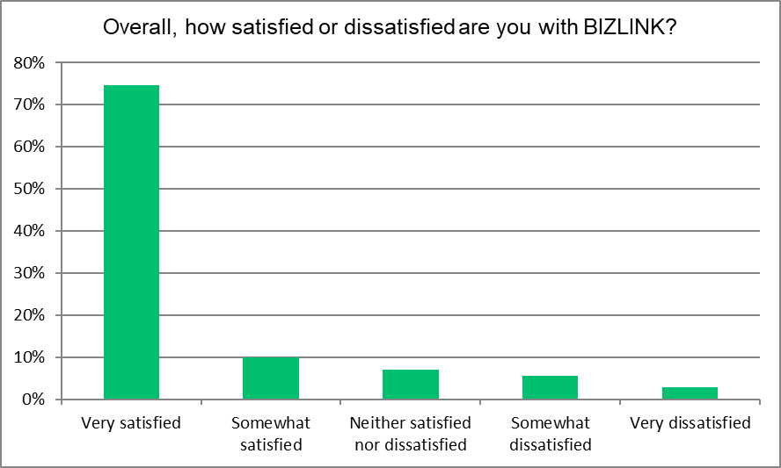

CONCLUSIONS
The Annual Client Survey aims to determine whether BIZLINK provides a service that meets the expectations of our clients and the National Standards for Disability Services. It is important to take all opinions from the perspective of our clients and use their feedback to improve our service. The results show that that majority of clients who responded to the survey have a positive view on their experience with BIZLINK:
- 85% (2020 87%) were satisfied with their Job Plan overall i.e. up-to-date, reviewed when needed, individualized
- 72% (2020 84%) are satisfied with the assistance of their Job Search Coordinator
- 87% (2020 79%) are satisfied with the assistance of their Support Coordinator
- 97% (2020 93%) felt service would not be affected or would improve if a complaint was made
- 79% (2020 90%) would recommend BIZLINK (that’s a score of 7 to 10)
- 85% (2020 92%) are satisfied overall with BIZLINK
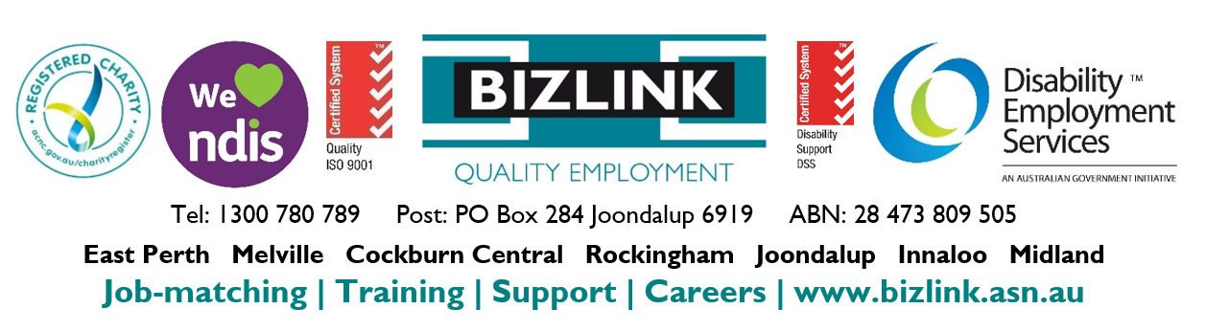
Survey results provide encouragement for what we are doing well and suggest means of improvement for areas where clients have raised concerns. BIZLINK aims to provide an excellent service; this report will be reviewed by the Quality Review Committee to discuss strategies for service improvement.

