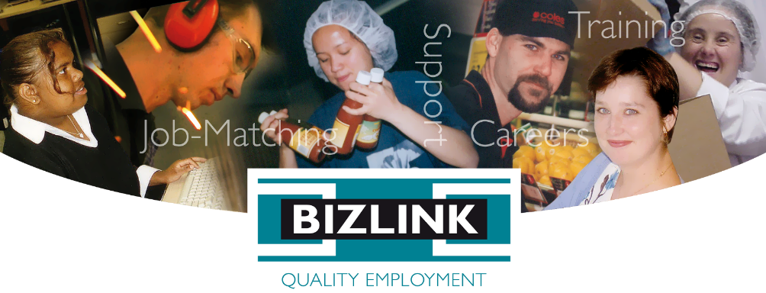April 2023 Volume 106

# BIZZYBODIES

## South Metropolitan Health Service (SMHS) Partnership

Picture of SMHS Facebook post with article: At SMHS, we are committed to having a workforce as diverse as our community is. This is why we’re very proud to engage in a new partnership with Bizlink Quality Employment, a Perth not-for-profit which provides disability employment support services and connect people with disabilities with employers. Fiona Stanley Hospital Cleaner and person with a disability, Eddie O’Meara, joined our team thanks to BIZLINK and credits them for helping him take the next step in his job search, and encouraging and guiding him towards long-term employment. With BIZLINK’s help, we look forward to seeing more staff with disabilities working at our SMHS hospitals into the future! 🏥 💜 
Read more about Eddie’s experience and our partnership with BIZLINK: https://smhs.health.wa.gov.au/.../Partnership-to-increase...

Pictured SMHS Facebook article with photo of   
Eddie, Tara, John, Jeff

Jeff McDonald, Senior Workforce Strategy Consultant SMHS, has worked with BIZLINK Quality Manager Tara Doyle, to develop the Service Agreement. Jeff organised the morning tea celebration of our partnership to increase the participation of people with disability in employment at Fiona Stanley, Fremantle, and Rockingham Hospitals, 24/02/2023. Paul Forden, Chief Executive SMHS, gave a passionate speech about inclusive employment and how inclusion of people with disability within organisations is just good business sense.

Tara responded and gave some background on our partnership with Fiona Stanley Hospital, where we have been successfully matching clients to quality jobs since 2014. Tara worked with BIZLINK clients back at PMH in the late 90s, where Fiona Stanley herself personally championed inclusion of people with disability. SMHS has provided many opportunities for quality jobs, speeches given by Daniel and Eddie, explain their employment journeys and you can watch them here [Testimonials - BIZLINK Quality Employment](https://www.bizlink.asn.au/testimonials.php).

Les Lowe, Job Search Coordinator, Janay Johnson and Nadiah Kamarudin, Support Coordinators, and Trevor Paterson, Operations Manager, represented BIZLINK. Les, Janay, and Nadiah are the primary contacts and supports at Fiona Stanley Hospital.

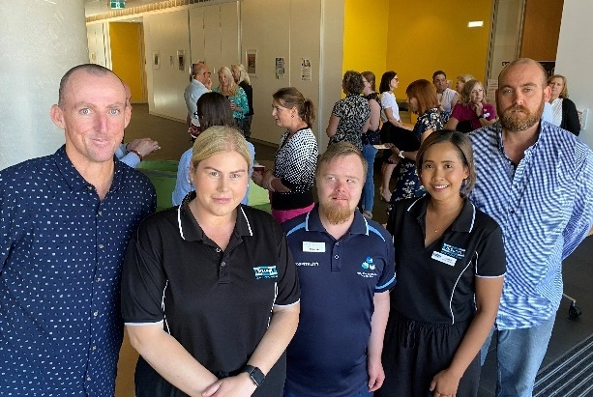

Pictured Eddie, Janay, Ben, Nadiah, Luke

## Annual Client Survey (DES)

Clients of our Disability Employment Service were invited to give feedback. BIZLINK sent an email to complete the survey or had access to the link via Facebook and QR Codes in the office.

The 2022 Annual Client Survey aimed to find out whether BIZLINK meets the expectations of our clients and the National Standards for Disability Services.



The results show that the majority of clients who responded to the survey have a positive view on their experience with BIZLINK:

* 92% (2021 85%) were satisfied with their **Job Plan** overall i.e. up to date, reviewed when needed, individualized.
* 92% (2021 72%) are satisfied with the assistance of their **Job Search Coordinator**.
* 92% (2021 87%) are satisfied with the assistance of their **Support Coordinator**.
* 60% (2021 55%) felt service would improve if a **complaint** was made.
* 89% (2021 79%) would **recommend BIZLINK** (that’s a score of 7 to 10).
* 93% (2021 85%) are **satisfied overall** with BIZLINK.

Survey results provide encouragement for what we are doing well and suggest areas to improve. Some of the comments:

*People are always amazing with helping me.*

*Approachable, diligent, compassionate and unlike other companies they do seem to care.*

*I like how my support coordinator helps me when I needed help the most.*

*Very good communication…I feel safe, heard and supported.*

The full report is on our website at the Annual Reports section [News & Info - BIZLINK](https://www.bizlink.asn.au/news-info.php).

## Anytime Client Survey

Clients can give feedback about BIZLINK at any time. We have a Survey Monkey link or QR Code at the feedback page on our website [Feedback - BIZLINK Quality Employment](https://www.bizlink.asn.au/feedback.php).

## SAI Global Quality Assessment

Each year an external auditor assesses if BIZLINK is meeting the National Standards for Disability Services. The Department of Social Services requires certification for all Disability Employment Services.

**Audit Participation**

The auditor will randomly select BIZLINK clients to assist in the assessment of our performance. Participation is voluntary, however, we appreciate your time if you can assist. If you are selected to give feedback, a BIZLINK employee will contact you to discuss times and the location for you to meet with the auditor to give your feedback.

This year our **Joondalup, Innaloo, Midland, and Rockingham sites** are part of the audit. Only clients linked to these sites will be asked to participate. The audit is scheduled for **19 June to 30 June 2023.**

## Quality Management / National Standards for Disability Services

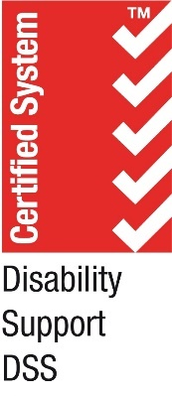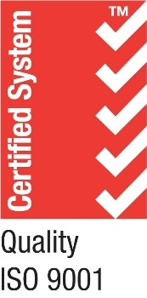BIZLINK Disability Employment Services (DES) come under the Disability Services Act. BIZLINK must provide services that meet the National Standards for Disability Services. BIZLINK is committed to achieving quality outcomes for people that use our service. SAI Global audits BIZLINK annually.

The National Standards for Disability Services (National Standards or NSDS) are in the BIZLINK Policy Summary Manual on our website [Standards & Policies - BIZLINK](https://www.bizlink.asn.au/standards-and-policies.php) or here [National Standards for Disability Services | DSS](https://www.dss.gov.au/our-responsibilities/disability-and-carers/standards-and-quality-assurance/national-standards-for-disability-services).

## Protecting Your Information

BIZLINK has achieved Right Fit For Risk (RFFR) Cyber Security Accreditation. The Department of Employment and Workplace Relations (DEWR) requires Providers, like BIZLINK, to meet and comply with certain information security requirements. RFFR Accreditation means that a Provider has met these requirements. More information [Right Fit For Risk Cyber Security Accreditation DEWR](https://www.dewr.gov.au/right-fit-risk-cyber-security-accreditation?fbclid=IwAR21JdvhDYrMpJ_XusULECELuc4J2hZqpm0GHCt4Rm0jj44RalcxTzXCEDY).

[](https://business.facebook.com/photo.php?fbid=668699605256652&set=a.503202565139691&type=3&__cft__%5b0%5d=AZUvxa8RvyyfzuEKxZQh94taiVU1uFwiSpewI8iBaGOcxDrcHltxz6x4ITZeMK1qjq5YjDKlzGkzKHlxiOiuSAc2OyoTVALyUrOJ_ons2JVEIiVCgNysSLVE0o6zcGuW3Ck&__tn__=EH-R)

## Coffee with the Premier

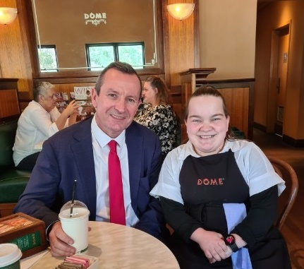Earlier this year, while working her shift at [Dome Kalamunda](https://www.facebook.com/profile.php?id=100063721802654&__cft__%5b0%5d=AZV3r6Tpprf043hxi1Jch1EkW98MJLATLQVVQY5_HD-pd24UluNYgxAn2dXR2xxiapaGSJkiyXBhiF7xSllz7VTx1fsqEjKmmANdGDvxIC4bEPpXInANSxRJMNBET1bQwE4&__tn__=-%5dK-R), Chloe met Premier Mark McGowan who took the time to sit for a photo. Chloe has been working with Dome Kalamunda since March 2022, her first job in open employment. Inclusive employers like her Manager Adam, provided this quality job and this opportunity for a brush with fame, which Chloe can’t stop talking about 😊

Pictured Premier Mark McGowan, Chloe

Burger King to Electronics Manufacturing Specialist

Since working as a kitchen hand, Joshua has been permanently employed as an Electronics Assembler at Motium. After initial training, both Joshua and Motium decided to formalise the skills and duties. Pictured with the Soldering Team Leader Marcus, Joshua demonstrates recent training as a Certified IPC Specialist. Joshua has worked hard to be a valued employee and now has the formal qualification to support his career goals, with plans to continue learning and gaining further industry training. Thanks to Motium and their staff for providing inclusive employment opportunities, a welcoming work environment and a partnership we are proud to promote.

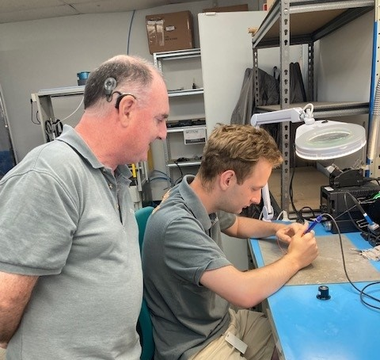

Pictured Marcus, Joshua

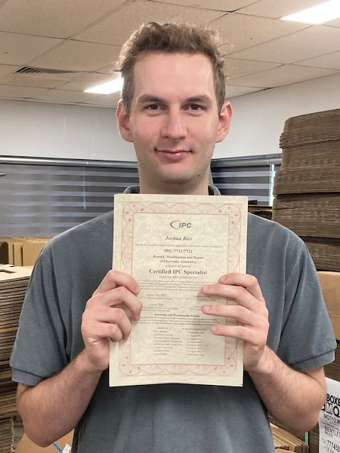

## National Reconciliation Week

National Reconciliation Week 2023 poster text reads:
Be a voice for generations


National Reconciliation Week (NRW) is a time for all Australians to learn about our shared histories, cultures, and achievements, and to explore how each of us can contribute to achieving reconciliation in Australia. The dates for NRW are the same each year; 27 May to 3 June.

The National Reconciliation Week 2023 theme is Be a Voice for Generations.

The theme encourages all Australians to be a voice for reconciliation in tangible ways in our everyday lives – where we live, work and socialise.

For the work of generations past, and the benefit of generations future, act today for a more just, equitable and reconciled country for all.

More information here [Home - National Reconciliation Week 2023](https://nrw.reconciliation.org.au/)

[Upcoming Events – National Reconciliation Week 2023](https://nrw.reconciliation.org.au/calendar/)

## Decade Club

BIZLINK is very proud of the stability and tenure of our team. We welcome Tracey into the Decade Club – Ten Years Service.

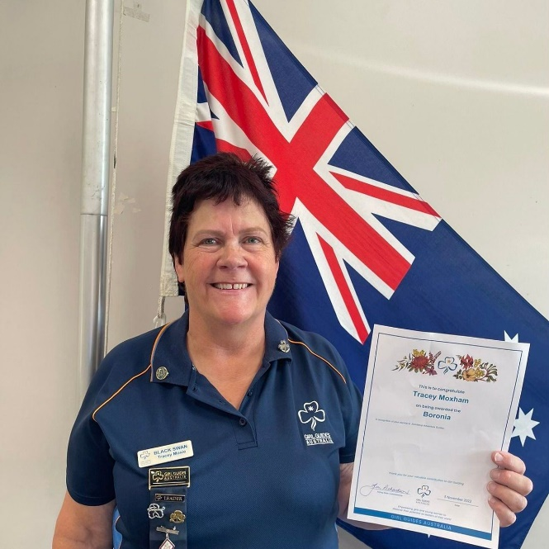

Pictured Tracey with her Boronia Award

Tracey, Support Coordinator, Innaloo, joined BIZLINK in March 2013. She moved to Perth from Portsmouth, UK with her husband and four children in March 2005. Prior to moving to Australia, she worked for the National Health Service as an Auxiliary Nurse in Maternity for 18 years theatres/wards. Tracey completed her Cert III and IV in Disability and worked for a couple of disability services before BIZLINK. In 2019 Disability Employment Australia (DEA) recognised DES staff who make a difference in the program and in the sector, Tracey was awarded with a 10-year service award.

In November 2022, Tracey was recognised with a Boronia Award for her service to Girl Guides. Tracey has been a Guides leader with Joondalup Adventure Girl Guides since 2015 working with Guides aged 7-10 years of age. Tracey was recognised for being a dedicated unit leader, who facilitates exciting programs allowing the Guides to challenge themselves to achieve their best.

## Making A Difference

BIZLINK staff are nominated for this service award for demonstrating service excellence in their efforts to secure, support and maintain quality employment or more generally, for going the extra mile to Make A Difference. Les (BIZLINK Melville) was recognised by an employer for a great job promoting BIZLINK and job matching clients to roles. Les has built a positive partnership with the Backbone Steel management team, and often comes in to see how current staff are going, and if there are any new opportunities. The employer acknowledged that BIZLINK ongoing support is a key point of difference of our quality service.

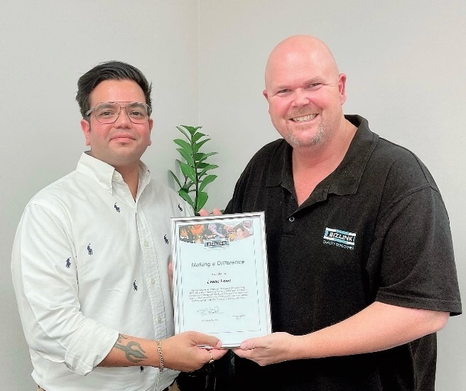

Pictured Abhi, Site Manager and Les Job Search Coordinator

## Your Privacy Is Important

Our Policy on Privacy includes information on:

* How we collect and handle your personal information.
* Who we exchange your information with.
* How you can access and correct your information, and how to make a complaint. These rules apply whenever we collect, use, or exchange your information.

Current policies and more information about privacy is on our website [Standards & Policies - BIZLINK Quality Employment](https://www.bizlink.asn.au/standards-and-policies.php).

### How to make a privacy-related complaint

To make a complaint to us about how we have handled your personal information refer to our Policy on Feedback and Complaints – see Complaints Process. If you are not satisfied with our response, you can complain to the Complaints Resolution and Referral Service or Department of Social Services or the Office of the Australian Information Commissioner (OAIC). You can make a complaint directly to the OAIC before contacting us. However, the OAIC recommends you try to resolve your complaint by contacting us first and giving us 30 days to respond.

**For further information on privacy or to lodge a complaint:**

**BIZLINK:**

Telephone 1300 780 789

Email [bizlink@bizlink.asn.au](mailto:bizlink@bizlink.asn.au)

Website [www.bizlink.asn.au](http://www.bizlink.asn.au)

**Office of the Australian Information Commissioner (OAIC):**

Telephone 1300 363 992

Email [enquiries@oaic.gov.au](mailto:enquiries@oaic.gov.au)

Website [www.oaic.gov.au](http://www.oaic.gov.au) / [Lodge a privacy complaint with us | OAIC](https://www.oaic.gov.au/privacy/privacy-complaints/lodge-a-privacy-complaint-with-us)

## Complaints Process

## Go for Gold

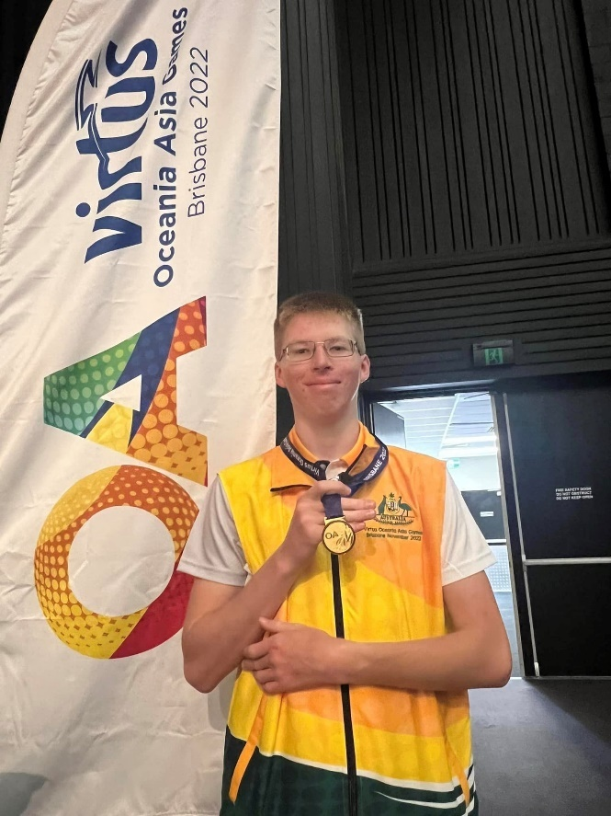

Pictured Josh

Josh Joined BIZLINK Midland as a school leaver. Josh had been regularly working at Spudshed. Job Search Coordinator, Luke, worked with Josh to develop interview skills, Josh aced an interview for night fill at Coles. While this was happening, Josh was training in Judo for the Brisbane Virtus Games (November 2022) with the goal of making the team. The Virtus games are an accessible elite sporting competition with competitors flying in from the Oceania Asia (OA) region. Josh earned a position to represent Australia on the squad. Josh was happy to be selected and didn’t go in with any expectations - Josh came home with Gold! - beating all the Australian and international competitors. Josh is continuing to work at Spudshed and Coles while studying at TAFE. BIZLINK is working with Josh to achieve employment goals and we look forward to seeing more sporting achievements.



## National Disability Services (NDS) - WA Jobs Expo

February 2023 an expo for all ACTIV staff in supported employment to meet with other service providers and gain information on NDIS and DES providers was held. BIZLINK attended the all-day event and met with several ACTIV staff to support them in their employment journey. Lee, Site Manager, Pauline, Employment Coordinator and Candy, Project Manager represented BIZLINK.

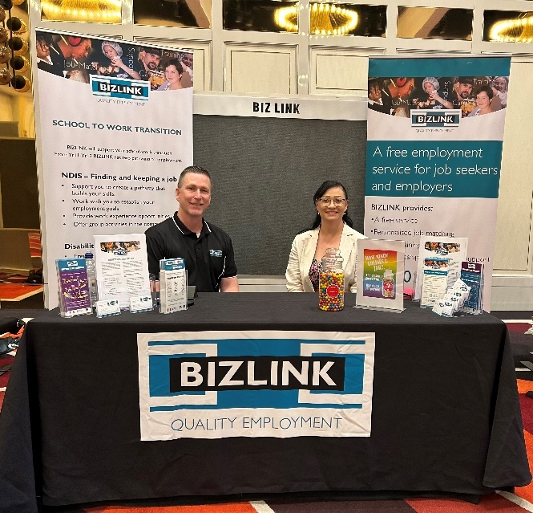

Pictured Lee Site Manager, Candy Project Manager

## NDIS News

Tom has been volunteering at MCCO (Margaret Court Community Outreach) with support from Project Officer, Thomas. Tom has been doing a fantastic job developing employability skills, relationships with fellow staff and effective communication. A regular session involves sorting items, packing them into individual portions, ready for food hampers. Tom’s long-term goal is to attend TAFE or further study and we are exploring these options.

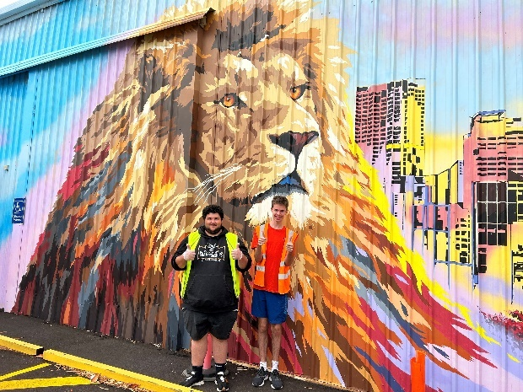

Pictured Thomas and Tom

## Coronavirus / COVID Update

While restrictions have eased, case numbers remain high, and we want to keep our staff and visitors safe. All the latest information is here [COVID-19 coronavirus: Latest updates (www.wa.gov.au)](https://www.wa.gov.au/government/covid-19-coronavirus/covid-19-coronavirus-latest-updates).

**If you are unwell stay home**

Staff can assist with contacting Centrelink and your employer if needed.

**COVID-19 symptoms** include fever, coughing, sore throat, and shortness of breath. More info at <https://www.health.gov.au/>.

**Wearing a Mask is Recommended**

There is no longer a mask mandate. Wearing one is still recommended when indoors and in close contact.**** You must wear a mask when directed by the Health Department.

**Stay Informed**

[Connect with us on Instagram logo
www.instagram.com/bizlinkqualityemployment](http://www.instagram.com/bizlinkqualityemployment)[Connect with us on Facebook logo
www.facebook.com/bizlinkqualityemployment/](http://www.facebook.com/bizlinkqualityemployment/)Your Coordinator will keep you up to date using your preferred method of contact. Stay up to date with BIZLINK Facebook and Instagram:

### Image of WA map with a bottle of COVID19 Vaccine Vaccinations

This State Government website assists with making an appointment for a COVID vaccine [Roll Up For WA](https://rollup.wa.gov.au/) Discuss individual needs with your support network and Doctor.

Consider getting the booster dose if you are eligible.

## Flu Vaccine

The Government advises that everyone six months and older is recommended to get an influenza (flu) vaccine each year. The flu vaccine protects you and those around you.

Discuss individual vaccination needs with your support network and Doctor.

Health Direct suggest having a Flu Vaccination in April or May for best effectiveness - [Flu vaccine FAQs | healthdirect](https://www.healthdirect.gov.au/amp/article/flu-vaccine-faqs).

More information here: [Influenza (flu) vaccine | Australian Government Department of Health and Aged Care](https://www.health.gov.au/topics/immunisation/vaccines/influenza-flu-vaccine).

Poster about Hand Hygiene, image of hands being washed and a count down timer of 20 seconds.
"Good Hygiene is in your hands. Wash your hands thoroughly with soap and water for at least 20 seconds to prevent passing on germs. Dry your hands. Togehter we can help stop the spread and stay healthy.  For mor information about Coronavirus (COVI-19) visit health.gov.au


As for Coronavirus, hand hygiene and mask wearing can help stop the spread of colds and flu. Stay home if unwell.

## Getting Email

Keep your email up to date to get information like a link to the latest BIZZYBODIES. Keep your contact details current - let your Coordinator know. Your personal information is protected by the Australian Privacy Principles, more information here: [Australian Privacy Principles | OAIC](https://www.oaic.gov.au/privacy/australian-privacy-principles).

## A picture containing logo Description automatically generatedBIZLINK NDIS

If you have or add **Finding and Keeping a Job** funding in your NDIS plan, together we can:

* Support you to create a pathway that builds your skills.
* Work with you to establish your employment goals.
* Provide work experience opportunities.
* Build work readiness skills.

**To Find Out More**

Call **1300 780 789**

[Email **projects@bizlink.asn.au**](mailto:projects@bizlink.asn.au)

## Getting Information Your Way

BIZLINK assists people with a range of abilities. Staff can read and explain this information, or we can provide the information in different ways, such as, another language or electronically, as needed. Please discuss with your Coordinator.

## Choose BIZLINK

BIZLINK is a West Australian, not-for-profit, employment service. BIZLINK is dedicated to securing and supporting inclusive employment in the Perth suburbs and has done so since 1992.

Whether you already have a job or are looking for employment, **choose BIZLINK for**:

* A free service.
* Convenience of 7 offices across Perth.
* Personalised job-matching.
* Individual one-to-one assistance.
* On-site training support and advice.
* Apprenticeship and Traineeship support.

**CONTACT**

**1300 780 789**

**To discuss how BIZLINK could be the BEST provider for you**

A person working at a hospital in the reception area cleaning

A person working on a computer

A person detailing a car with a high pressure cleaner



