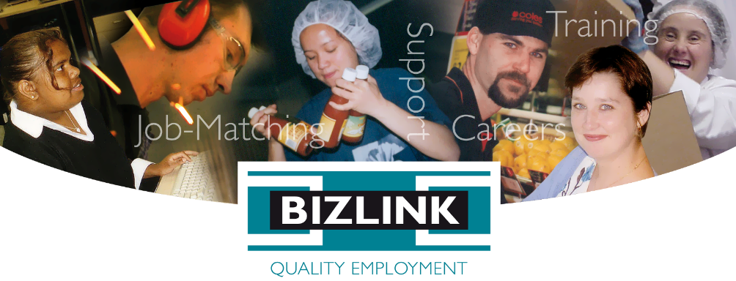
December 2023 Volume 108

BIZZYBODIES

Employer of the Year 2023
Winner
City of Rockingham
Partner since 2010

In an interview for an International Day of People with Disability feature article in the West Australian, City of Rockingham CEO Michael Parker said:
“The City is proud to be an equal-opportunity employer and we appreciate that people from all walks of life can make a positive contribution to our organisation. Our association with BIZLINK has enabled us to grow a more inclusive and diverse workforce, and these team members have all made a positive impact on the atmosphere and culture of our workplace. We were delighted to receive the Employer of the Year Award from BIZLINK, with whom the City has had a longstanding relationship. BIZLINK does a terrific job, and we look forward to continuing to collaborate with them in the future.”
The City of Rockingham was nominated by Jay Cross, Site Manager East Perth / Innaloo.

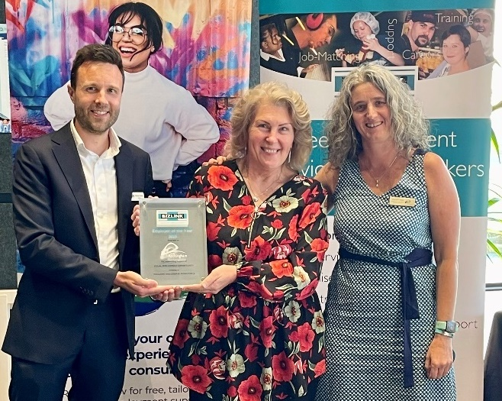
Michael BIZLINK Chair, Brenda, Coordinator Human Resources, Mary-Jane Manager Community Safety and Support Services.
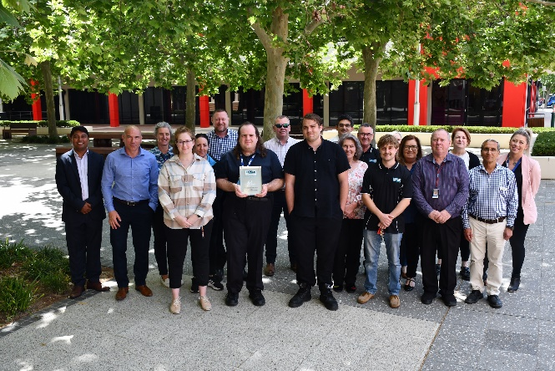
The City of Rockingham feature photo from their Facebook page

Employer of the Year 2023 Finalists

Joondalup DC
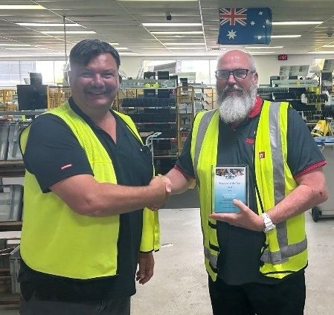
Dave and John
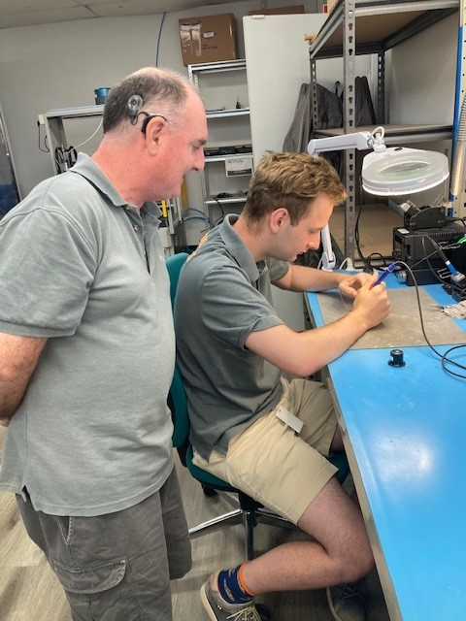
Marcus and Josh
Port Coogee
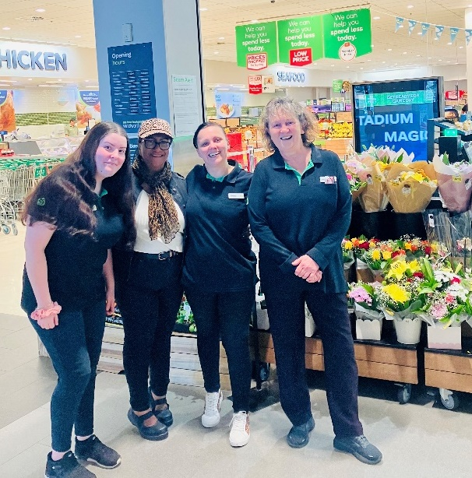
Sharni, Rosemarie, Janaya, Jennifer
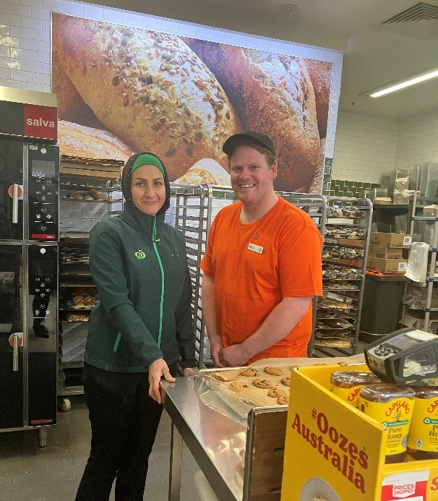
Leila and Mark

JAD Enterprises
JAD Enterprises was nominated for the BIZLINK Employer of the Year Award 2023, by Dave, Support Coordinator and Sean, Job Search Coordinator. JAD provide quality employment opportunities and currently have four of our clients as part of the team. In January 2022, Sean secured employment for our first client at JAD. Since then, he's worked closely with David White, JAD General Manager, to secure three more positions in a specialized auto electrician role. Our clients come from diverse backgrounds, each with unique skills to offer innovative employers. JAD has shown that with flexibility and adaptability, each employee can succeed.
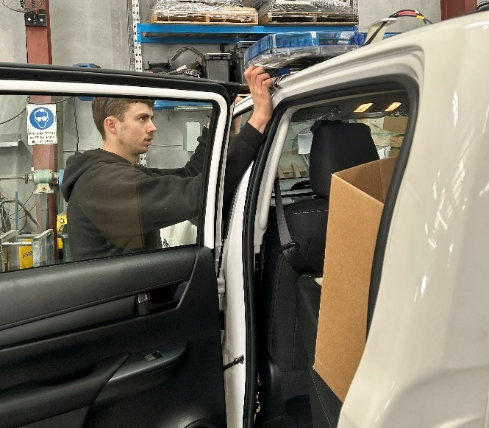
Jules working on car
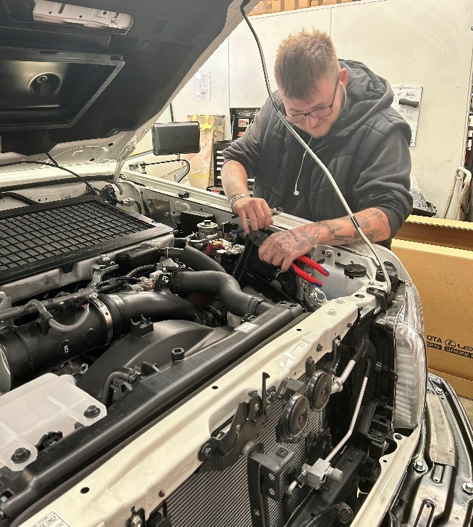
Mak working on car

Ritz Party Hire
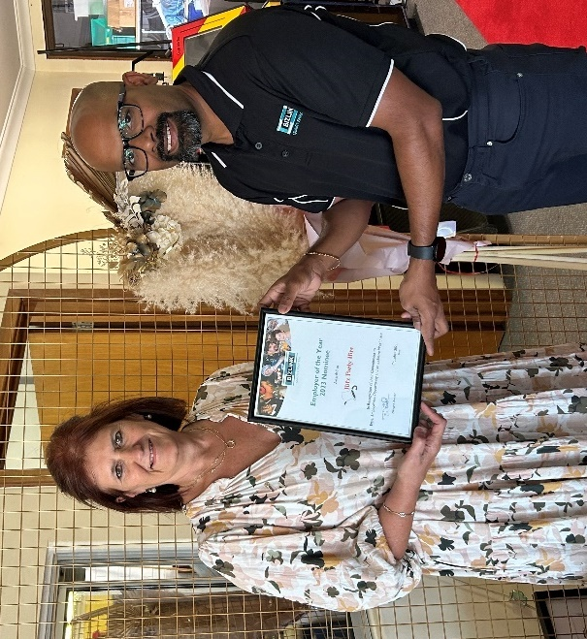
Michelle employer and Suresh
Ritz Party Hire, Rockingham, was nominated by Suresh, Job Search Coordinator for the BIZLINK Employer of the Year Award 2023. Ritz has been supporting BIZLINK clients since 2018. Ritz is a family business, specialising in servicing Rockingham and Peel providing party hire products.
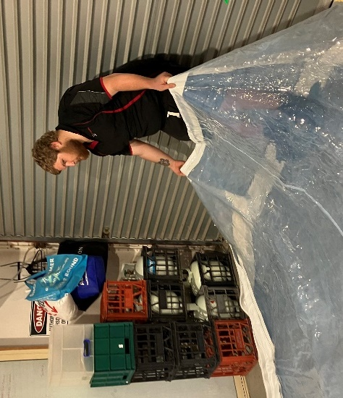
Jay preparing a marquee
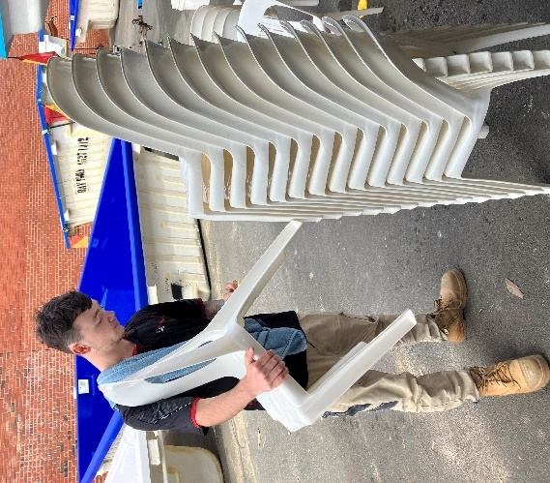
Konner getting chairs ready for function

Annual General Meeting
The BIZLINK AGM held on 17 October 2023 was a celebration of significant achievements. Together with the City of Rockingham being awarded the 2023 BIZLINK Employer of the Year, several staff were acknowledged for their contributions.
Copies of the 2022-2023 Annual Report are available at the “News & Info” page on our website www.bizlink.asn.au or call 1300 780 789 to have posted or pick one up from a BIZLINK office.
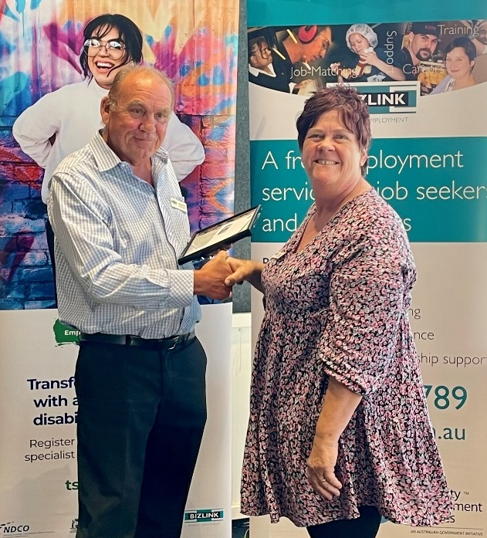
Brian presenting Tracey with the 10-year BIZLINK Service Award

BIZLINK Service Awards
The BIZLINK Service Award was introduced in 2020 to acknowledge each decade of tenure (10 year / 20 year). The following staff have attained important milestones, we thank them for their years of dedicated service:
BIZLINK Service Awards - All Recipients

20 Years | Tara Doyle | Lisa Campbell | Lee Holland  Sean Deasy | Brian Park
10 Years | Lisa Fuentes | Tina Zemzars | Troy Sabetta  Lindsey Rutherford | Liz Zidich  Trevor Paterson | Luis Galaz  Debbie Finn | Julie Needham  Charlie Lenzo | Yvonne Duffield*  David Smith | Carol Porter | Tracey Moxham

DEA Service Awards
This year we nominated Lindsey Rutherford, Quality Officer, and Tracey Moxham, Support Coordinator for the Disability Employment Australia (DEA) Commemorative Medal. These awards recognise and acknowledge DES staff who make a difference in the program and in the sector. DEA has honoured employees with a medal of service acknowledging 10, 15 and 20 years, and a special commemorative medal for lifetime achievement of 25+ years working in DES. The award was introduced in 2019. BIZLINK has had five employees awarded the lifetime achievement award of 25+ years working in Disability Employment Services: Trevor Paterson, Tara Doyle, Luis Galaz, Troy Sabetta and Lisa Campbell.
DEA Service Awards - All Recipients
25 Years
Trevor Paterson, Tara Doyle, Luis Galaz, Troy Sabetta, Lisa Campbell
20 Years
Lee Holland, Les Lowe, Sean Deasy, Liz Zidich, Brian Park, Pauline Donnelly
15 Years
Rosemarie Horsley, Lisa Fuentes, Tina Zemzars, Lindsey Rutherford, Tracey Moxham
10 Years
Stephenie Fielding, Lindsey Rutherford, Tracey Moxham, Debbie Finn, Julie Needham, Rosemaree Bloomfield, Charlie Lenzo, Yvonne Duffield*, David Smith, Janet Sein Win, Harveena Singh*, Carol Porter
inducted this year | *past employee
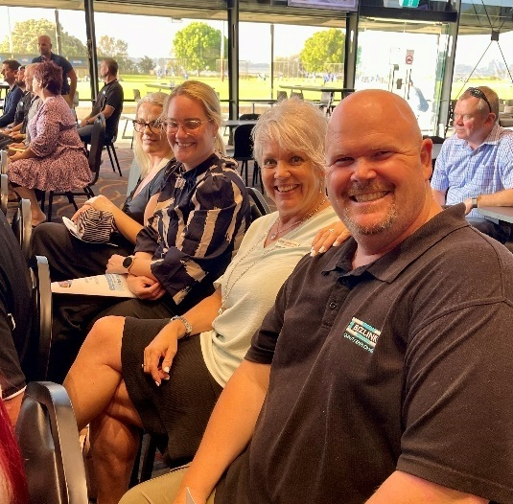
AGM attendees Les and Cush, with Lauren from Employer of Year Nominee PMB and Tenille

Pauline Donnelly
Tara Doyle Award Winner 2023
Tara Doyle, Quality Manager, presented Pauline Donnelly, Employment Coordinator Rockingham, with the 14th Award. The following recipients remain dedicated to BIZLINK, and we continue to benefit from their contribution: Sean Deasy inaugural winner, Troy Sabetta, Debbie Finn, Liz Zidich, Charlie Lenzo, Lindsey Rutherford, Lisa Campbell, Julie Needham, Trevor Paterson.
The Board initiated this award to provide an opportunity to recognise an exceptional employee who represents everything that BIZLINK stands for. Tina and Steph put together an amazing testament to the incredible contribution Pauline has made, not only to BIZLINK, but many people with disability over her career. Our team makes BIZLINK the amazing organisation it is, and Pauline has been key to the success of Rockingham. Pauline has been committed and diligent, achieving results, which means people with disability getting and keeping quality jobs.
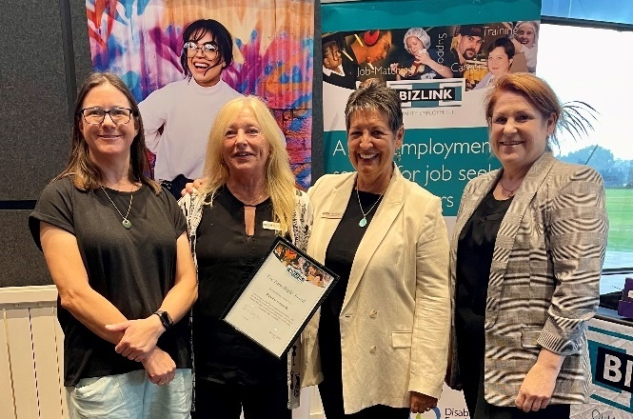
Tara, Pauline, Tina, Stephenie

Nominees Tara Doyle Award
We have so many employees who step up to challenges and go above and beyond to make a difference, we had four strong nominations.
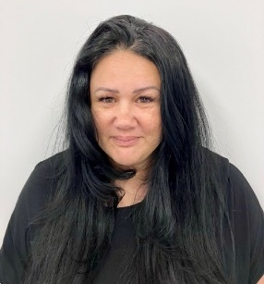
Shar
Sharleis (Shar), Employment Coordinator, Rockingham nominated by Kadj, Site Manager Cockburn.
Rosemarie, Support Coordinator, Cockburn, nominated by Kadj.
Paris, Job Search Coordinator, Cockburn, nominated by Kadj.
Sean, Job Search Coordinator, Joondalup, nominated by Lee Holland, Site Manager, Clarkson & Joondalup.
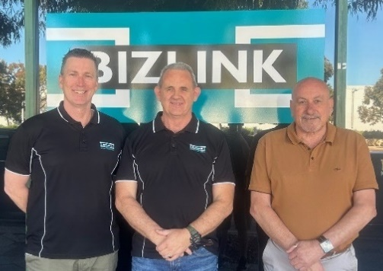
Lee Sean Trevor
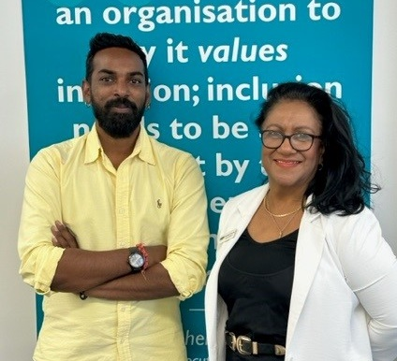
Kadj and Rosemarie
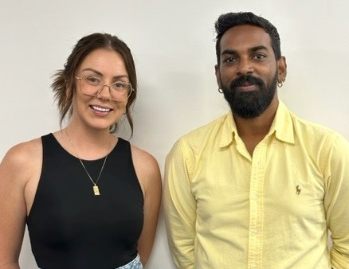
Paris and Kadj

Codie’s AGM Speech
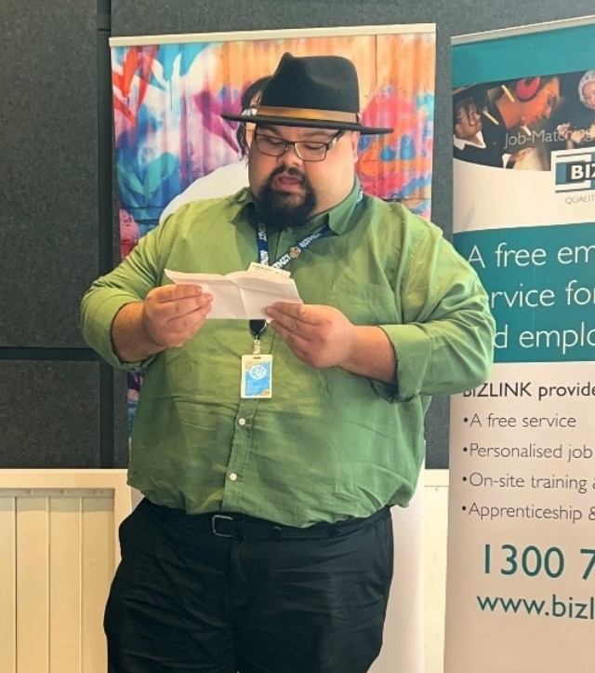
Codie giving speech at the BIZLINK AGM
“Good evening and thank you for having me tonight. My story begins as a candidate for the traineeship position with the City of Rockingham. Instead of your standard interview the city did a discovery day together with their candidates. This process didn’t have the dread or stress that someone might feel going to an interview but instead had a warm and friendly approach. I said on that day that I wish more interviews could be like this, later on that afternoon I got the call that I was successful for the position.
10 months and 12 days I have been with the City of Rockingham and in that time, it has been a life changing experience. Through the support of BIZLINK and the City of Rockingham I was able to overcome personal barriers and obstacles, expand my skills and knowledge and improve my mental health. I am very grateful that BIZLINK and the City of Rockingham has given me this opportunity.”

Kellan’s AGM Speech
“My name is Kellan, my journey with BIZLINK started in September 2021 after a referral from Centrelink. The initial support from BIZLINK encouraged me to maintain my well-being to be at optimal levels and later to get a job I was working with Abhi after overcoming a few hurdles Les assisted me in securing a role at Total Tools O'Conor.
The business specializes in selling all types of tools I started to work in the welding section as I previously worked as a boiler maker welder for many years. At the beginning of my role I had an unfortunate accident and I burned my hand while I was cooking at home. The immediate support and reassurance from Luis and Les and my employer's flexibility reassured and gave me the confidence that I needed especially at the start of a new job.
While I was managing the burn I managed to work and my employer was very flexible and supportive I did not take time off. My manager Jeff adjusted my duties and timetable to ensure I was able to perform my role while managing the burn with medical assistance. The initial support was crucial for me to stay focused and to be able to work.
I felt reassured that it was all okay, at all times the regular onsite support from Luis at work provided me reassurance that I can talk about work and other issues we have talked about my progress and goals and aspirations. I have a good employer that supports me and provides me with regular feedback on my role. I've also received very good reviews and feedback from customers.
I've gained considerable experience and confidence in my role. I've overcome difficulties and challenges. Now I work 4 days a week I have a permanent part-time job that allows me to manage my well-being on my days off I'm surfing I'm now working across all departments in the store. Thank you.”
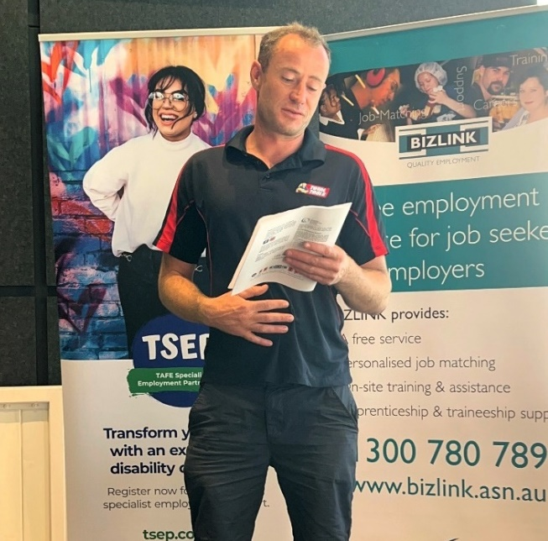
Kellan giving speech at the BIZLINK AGM
Codie and Kellan’s speeches are on our website, together with other testimonials of our service Testimonials - BIZLINK Quality Employment

West Australian Feature

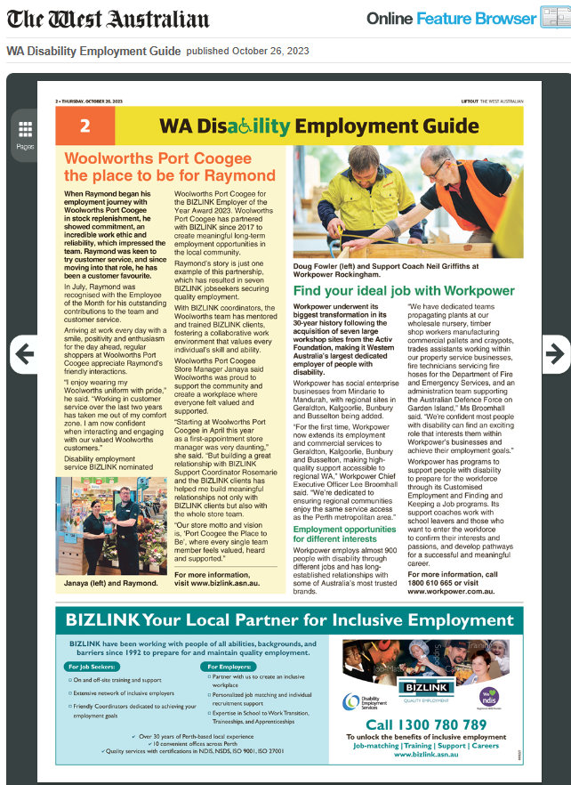

International Day of People with Disability IDPwD
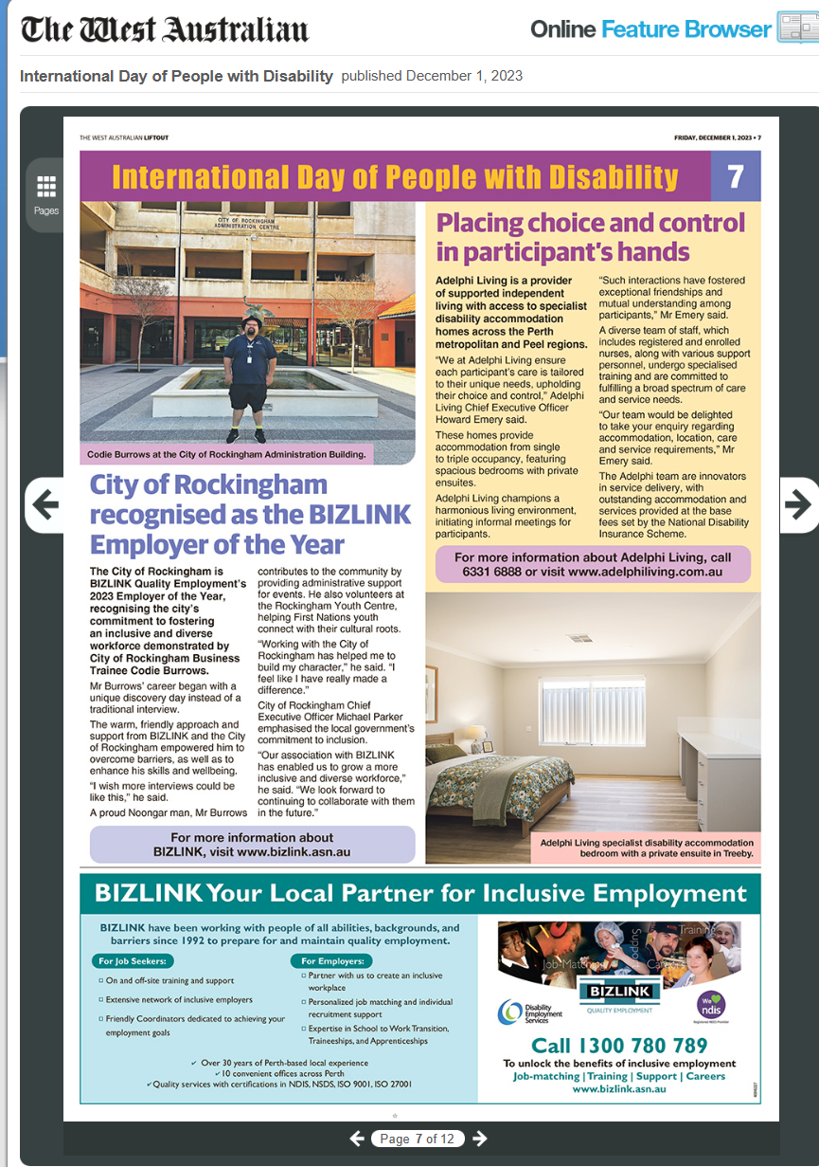

IDPwD aligns with Australia’s Disability Strategy 2021-2031 and its vision for an inclusive Australian society. Disability in Australia:
- 4.4 million people with disability live in Australia.
- 53% of people with disability aged 15-64 have a job.
Visit the website to find out more and access stories, videos and resources www.idpwd.com.au

BIZLINK Clarkson
The Clarkson office opened for business in August 2023. Starting out with a small team, Lee Site Manager Clarkson / Joondalup, Bronnie Job Search Coordinator and Meg Employment Coordinator. Our Support Coordinators from nearby offices will assist whilst we build the register of workers.
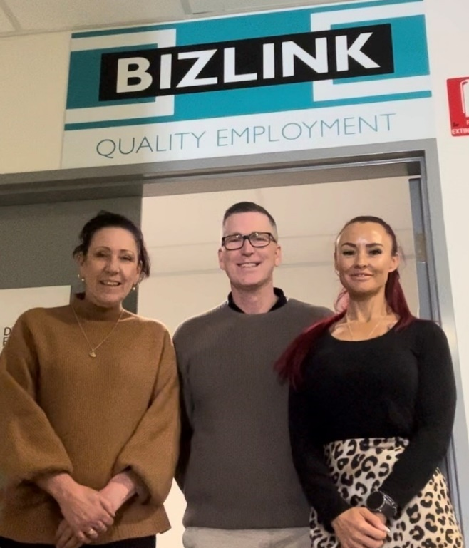
Bronnie, Lee, Meg out the front of the Clarkson office

First BIZLINK Clarkson Job Start
Ashley faced an unexpected setback when he was laid off from his previous job of 12 years due to the impact of COVID in March 2020. With BIZLINK support he was quickly matched to a great role.
His first job search meeting was with Bronnie, newly appointed Job Search Coordinator, in September 2023, not long after being registered by Meg at the new BIZLINK Clarkson Office.
Bronnie introduced Ashley to Bec, Manager Quinns Rocks BWS, who had an opening for a liquor store attendant. BWS funded Ashely's online RSA, he then completed an online video interview and started working in early October 2023.
With the help of Dave, Support Coordinator, Ashley has settled in and is loving his new job and said "all the BWS Team are very nice people. I’m fitting in well and helping out with extra shifts in Joondalup and Wanneroo BWS stores." Ashley nailed his training and upskilling to the point that he can set his sights high with BWS and is hoping to continue a career within the company.

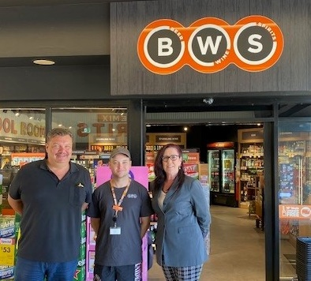
Dave, Ashley, Bronnie
Office locations are on our website Contact us - BIZLINK Quality Employment
Making A Difference
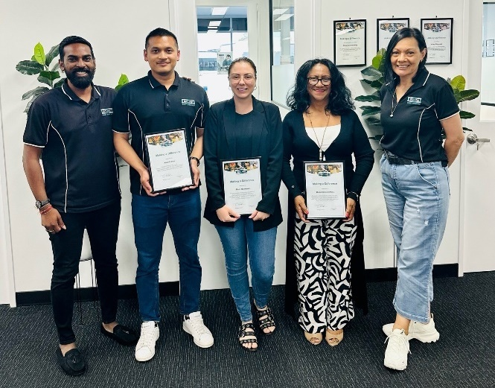
Kadj, Khalif, Paris, Rosemarie, Ellen
BIZLINK staff can acknowledge exceptionable efforts of their colleagues with a Making A Difference award. These awards recognize employees that demonstrate service excellence in their efforts to secure, support and maintain quality employment or more generally, making a difference in the life of a person.
Khalif for 'Exceptional teamwork and support. Whilst a Job Search Coordinator, Khalif regularly assisted support whilst successfully managing a caseload of job seekers.’
Paris for 'Building a successful employer partnership with AYLA. A demonstration of what BIZLINK strive for – creating meaningful and sustainable employment.'
Rosemarie for demonstrating our value of Team Work. When faced with a tight deadline, Rosemarie was quick to assist and has created numerous articles for our social media.'

Staff Promoting BIZLINK
Thanks to staff that are out and about promoting BIZLINK at community events which are featured on our Socials

John Tonkin College Education Support Centre
Adam, Pauline, Suresh, Anne and Wayne represented BIZLINK Rockingham at the John Tonkin College Education Support Centre Disability Expo held at the Mandurah Forum on 20 October 2023.
The BIZLINK team enjoyed meeting students, families, teachers and members of the community to discuss how BIZLINK can work with them either through our Disability Employment Service and / or our NDIS programs.
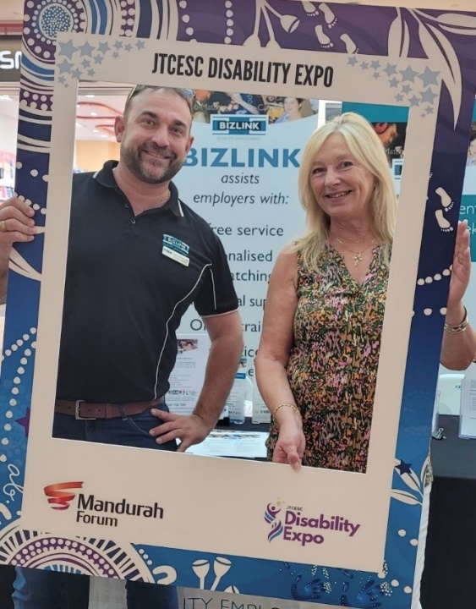
Adam and Pauline
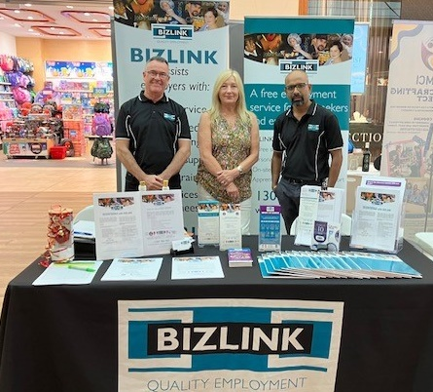
Wayne, Pauline, Suresh

Mandurah Jobs Fair
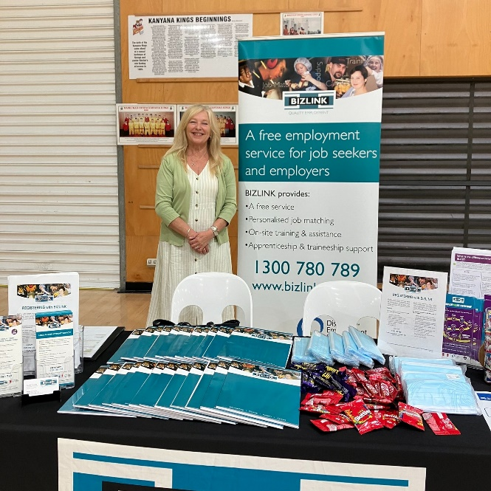
Pauline
Pauline, Employment Coordinator and Suresh, Job Search Coordinator, represented BIZLINK at the City of Mandurah - Mandurah Jobs Fair at the Mandurah Aquatic and Recreation Centre on 9 November. This event provided jobseekers with opportunities to connect directly with local employers and explore employment and training opportunities.

Australian Para Ice Hockey
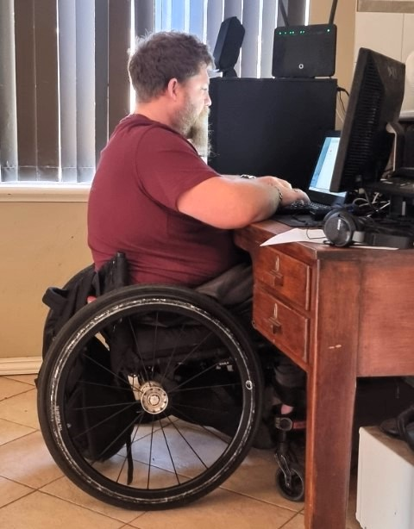
Bryan working from home
Bryan recently earned an opportunity to represent Australia in the Para Ice Hockey team. Bryan's commitment to his role at the Public Transport Authority (PTA) / Serco has been exemplary. He plays an essential part in the team’s success, particularly in managing smart rider cards, using web chat, and handling customer calls efficiently from his remote work setup. His professionalism, dedication, and strong work ethic are reflected in his sporting achievements.
Bryan has been at PTA/Serco 4 years, he works in customer service, and arranged to work from home due to a low immune system. He attends staff meeting and information sessions once a month.
Bryan has competed at the Commonwealth games in shot put, and plays basketball at Mirrabooka recreational centre. He is attending a training camp for the European Ice Hockey championship in December. We wish Brian well for his sporting endeavours.

PMB - Perfect Match
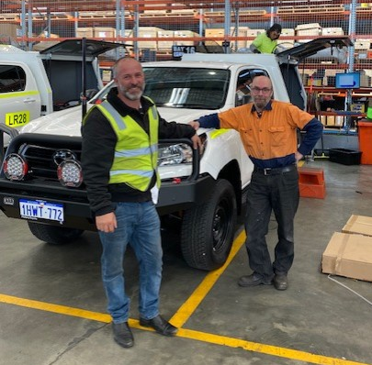
Troy Perth Motor Bodies and Simon
Simon registered with BIZLINK in October 2022, seeking support to gain employment after being unemployed for an extended period of time, after running his own successful business. Simon was initially cautious in his journey to gaining employment, concerned about the impact on his health and wellbeing. Cush, Job Search Coordinator BIZLINK Melville, reassured Simon and explained he would be an asset to any employer. Simon’s extensive knowledge, experience, and capabilities in vehicle mechanics led Cush to approach one of BIZLINK Melville's top employers, Perth Motor Bodies (PMB), for a position. Simon’s impressive resume resulted in a position being offered in their electrical department. Simon has been excelling at PMB and his positive attitude and eye for detail has exceeded the expectations of PMB, who provide glowing feedback to Tenille, Support Coordinator BIZLINK Melville regularly. As a result of his impeccable work ethic, Simon has been provided with a wonderful opportunity to help in the rebuilding of a vintage vehicle for the owners of PMB. This is a wonderful achievement for Simon, BIZLINK and PMB. Showing the incredible results of teamwork between companies and individuals, working together to reach a common goal.

PMB - Coworker Training
BIZLINK Melville staff presented Coworker Training to the supervisors and managers at Perth Motor Bodies (PMB). Coworker Training assists staff to improve their knowledge of the role of BIZLINK and their approach to facilitating workplace inclusion. Luis, Team Coordinator, led the Coworker Training with support from Cush, Job Search Coordinator, and Tenille, Support Coordinator.
PMB management have requested further training for their employees to encourage inclusion, understanding and support for each other. Management indicated they are excited to improve their support strategies for all their staff.
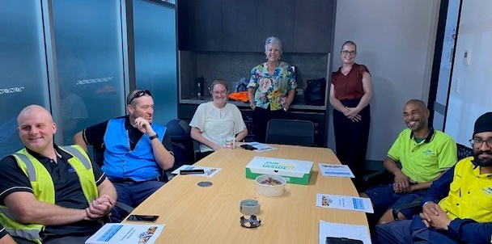
Perth Motor Bodies team with Cush and Tenille

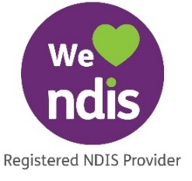
BIZLINK NDIS
If you have or add Finding and Keeping a Job funding in your NDIS plan, together we can:

- Work out your employment goals.
- Provide work experience opportunities.
- Build work readiness skills.
To Find Out More
Call 1300 780 789
Email ndis@bizink.asn.au

Getting Information Your Way
BIZLINK assists people with a range of abilities. Staff can read and explain this information, or we can provide the information in different ways, such as, another language or electronically, as needed.
BIZLINK Office Closure for Christmas and New Year
All BIZLINK Offices will be closed from
5 pm Thursday 21 December 2023 and reopen 8.30am Tuesday 2 January 2024
If you have support needs, your Coordinator will contact you as agreed. Appointments cannot be booked in the office as the Department of Social Services is officially closed. Appointments are booked through their system.
Please contact your Coordinator direct or call
1300 780 789 with any queries.
Everyone at BIZLINK wishes you a safe Christmas and Happy New Year. We look forward to working with you in 2024.

CONTACT
1300 780 789
To discuss how BIZLINK could be the BEST provider for you

