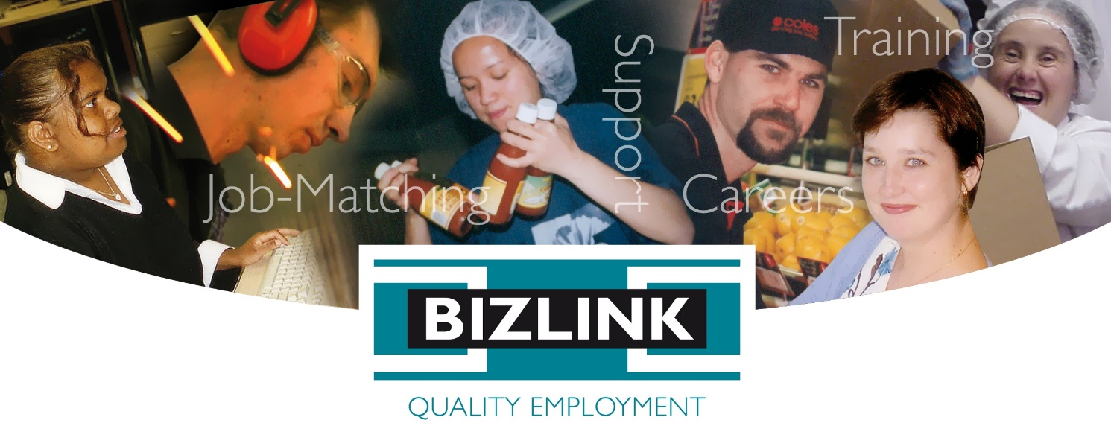

Disability Employment Strategy

Aim and Scope
The BIZLINK Disability Employment Strategy aims to improve employment, recruitment and retention of people with disability. The Disability Employment Services Deed requires BIZLINK to “produce and implement a Disability Employment Strategy.” The Deed defines the Disability Employment Strategy as “a strategy implemented by the Provider designed to attract, develop and maintain employees with disability within the Provider’s own organisation”.
This strategy covers activities related to the employment participation of people with disability both within and external to BIZLINK. It includes the:
- Recruitment, training and retention of BIZLINK employees with disability
- Promotion and job-matching of people with disability
- Training and retention of new or existing employees with disability
- Disability awareness training

Key Principles
Our strategy is based on the following key principles:
- We value an inclusive and diverse workplace
- We recognize that people with a disability have diverse knowledge, skills, abilities and aspirations
- We believe people with disability can achieve sustainable open employment given a good job-match and appropriate supports

Strategy Objectives

Objective 1. Increase the participation of people with disability in employment
Skills gaps, skills shortages, an ageing workforce and labour shortages are issues of concern for all employers. It is in each employer’s best interest to market itself as an employer of choice by adopting innovative recruitment and retention strategies. This can include strategies to explore relatively untapped labour pools and invest in the recruitment and development of workers with disability.
Some 20% of the Australian population identify as having a disability. Employing more people with disability makes good business sense for a range of reasons, including the following:
- Attracting, retaining and developing the capacity of people with disability assists an organisation to be seen as an employer of choice, particularly when demand for skilled and talented employees increases
- People with disability offer varying perspectives, experience and knowledge which can add value to an organisations culture
- Increasing the diversity of workplaces promotes interaction, which enhances knowledge and awareness of, and competence in, working with people from a range of backgrounds.

BIZLINK Employee Recruitment
To attract people with disability to apply for employment with BIZLINK and facilitate engagement through our recruitment procedures BIZLINK Managers and employees involved in recruitment processes will:
- Be aware of the BIZLINK Policy on Equal Employment Opportunity which ensures that employee selection practices within BIZLINK are based solely on merit and are not influenced by extraneous factors, including sex (gender), marital status, pregnancy, sexual orientation, family responsibility or family status, race, religious or political conviction, impairment, disability or age.
- Consider the content of our job advertisements and our website as regards attracting people with disability to apply for positions.
- Provide flexible interview and selection processes. Providing additional assistance to any applicant as required to explain the selection process and how best to address the Selection Criteria and prepare for the interview.
- Consider inviting applicants for a workplace visit prior to a formal interview to meet members of the BIZLINK team and be more comfortable with the work environment.
- Consider choosing to convene applicant interviews in a less formal environment and modifying the room set-up to make it welcoming and relaxed.
- Consider work trials, work experience, School Based Traineeships, Work-based Traineeships, flexible employment options, including naturally occurring vacancies, job creation, job restructuring and job sharing to engage people with disability.

Collection of Equity Data
BIZLINK employees are asked to complete the ‘Applicant and Employee Details’ form which includes an optional section regarding Equity Data including identifying as having a disability. BIZLINK will encourage employees to provide Equity Data and will assure employees that providing such information will not negatively affect them.

People with a disability registering with BIZLINK
To attract people with disability to register with BIZLINK for their employment service to build our reputation as a service of choice for employers seeking to engage people with disability:
- Managers will facilitate service access through our policies, procedures and employee training.
- The Managing Director will set registration targets to increase the number of clients using BIZLINK services, whilst maintaining high levels of service performance e.g. Star Ratings.
- Employees will promote BIZLINK as a service that supports people with disability, particularly as regards direct registration pathways via Schools and Community-based organisations.
- Employees will seek out community partnerships with Schools and Mental Health Units to share resources and promote the registration of people with disability.

Employers Recruiting BIZLINK Clients
BIZLINK will promote people with disability to employers to increase their participation in employment by:
- Providing job-matching and on-the-job support to meet the individual needs of each person with disability and the employers requirements.
- Reference this strategy to provide information to employers (co-workers) on how best to engage and retain people with disability.

Objective 2. Improve the job-retention rate of people with disability.

To retain BIZLINK employees with disability:
- Management will provide opportunities for skills and career development.
- Managers will be encouraged and supported to provide individually designed professional development opportunities for all BIZLINK employees in accordance with their Performance Appraisal, Key Position Requirements and Training Record.
- Managers may implement flexible employee support strategies including mentor support and holistic or pastoral care (considering broader issues which may be outside of work e.g. personal and social wellbeing, health, social issues and emotional support) and will utilise community or natural supports wherever appropriate.
- Managers and employees will be aware of the BIZLINK Policy on Equal Employment Opportunity which ensures that employee training and promotion practices within BIZLINK are based solely on merit and are not influenced by extraneous factors, including sex (gender), marital status, pregnancy, sexual orientation, family responsibility or family status, race, religious or political conviction, impairment, disability or age.
- Managers are encouraged to access education and training (including work-based traineeships) to continuously improve and enhance the skills and knowledge of BIZLINK employees.
- People with disability who resign or exit BIZLINK will be encouraged to complete an exit survey/interview in line with the BIZLINK policy and procedures on the exit interview for all employees. This information can be used to improve our retention and attraction of people with disability.

Employee / Employer Training
BIZLINK will provide employees and employers (co-workers) with information and/or opportunities for training and education regarding creating and maintaining a supportive and inclusive workplace:
- Managers will provide resources and seek out training opportunities to ensure that all employees have access to information regarding the support of people with disability, that can be shared with employers (co-workers).
- BIZLINK will offer disability awareness training for employees and provide co-worker training to employers as needed.
- Co-worker Training offered by BIZLINK will be flexible and adapted to meet the employer’s needs. It can be a formal training session on or off-site or ongoing informal advice, support and mentoring.

Fostering a Culture of Inclusion
BIZLINK will promote events that raise awareness of disability issues, achievements and celebrations, for example, BIZLINK Employer of the Year Award, which promotes inclusive employers and people with disability in quality employment in diverse roles. International Day of People with a Disability, using, for example, client newsletter, Facebook and posters as appropriate.
Positive communication and attitudes are encouraged from the perspective that the language and terminology used provides direct evidence of employee’s values e.g. employees speak positively and respectfully about people with disability and avoid the use of labels or derogatory language with regard to age, gender, race, culture, religion or disability.
BIZLINK will promote www.jobaccess.gov.au as a site that provides useful information to improve disability awareness and inclusion.
BIZLINK will share this Disability Employment Strategy as a resource for our employers who currently engage or who are seeking to engage people with disability.

References
National Standards for Disability Services
Australian Human Rights Commission Act 1986 (Cth)
Disability Employment Services Deed
National Disability Strategy 2010–2020

Images
Aboriginal and Torres Strait Islander people are advised that the BIZLINK logo contains images of people who have died. We have family permission to use these images.

Review
Management will review this Disability Employment Strategy every three years, however, if at any time the legislative, policy or funding environment is so altered that the document is no longer appropriate in its current form, it will be reviewed immediately and amended accordingly.

About BIZLINK
BIZLINK is a leading West Australian not-for-profit disability employment service. We selectively match job seekers to fill the criteria of each vacancy and provide individualised on-site training, support and advice. Australian Government funding makes our service FREE.
Servicing the Perth suburbs since 1992, we have a network of hundreds of employers that benefit from our job matching and on-site training. We achieve reduced turn-over, lower absenteeism and employees who produce the quality and quantity to meet employer needs.
When making a choice, unlike many other providers, BIZLINK is:
- WA based and services only the Perth metropolitan
- Not-for-profit - all our funding goes into our service, not to shareholders
- Dedicated to securing and supporting inclusive employment in the Perth suburbs
- We assist working age people with all types of disabilities, barriers and backgrounds
- Tailored to your individual needs. We work with you to achieve your employment goals and secure sustainable ongoing open employment
- Experienced in personal job-matching and providing individual assistance including on and off-site training and support
- Quality endorsed with Disability Support Certification and ISO 9001 Quality Management

Getting Information Your Way
BIZLINK assists people with a range of abilities. Staff can read and explain this information or BIZLINK can provide the information in different ways, such as, large print, another language or electronically; e.g. emailed to you as a word document, as needed. Discuss with your Coordinator or contact BIZLINK.

Like Us on Facebook
BIZLINK has a Facebook page. We use it as an extension of our Bizzybodies newsletter and to connect with us and stay informed. Our Facebook page promotes our service, shares good news stories, provides relevant Department updates and shares information about BIZLINK services
www.facebook.com/bizlinkqualityemployment

Website
Our website provides information about BIZLINK for job seekers, employers, schools and community organisations. We post our policies, reports and newsletters to the website www.bizlink.asn.au
BIZLINK acknowledges the support of the Australian Government Department of Social Services which provides Employment Support Services funding.

1300 780 789
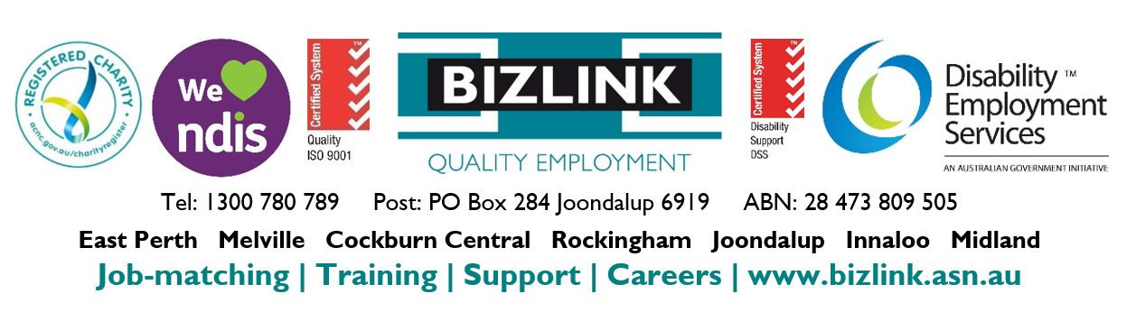
To discuss how BIZLINK could be the BEST provider for you

