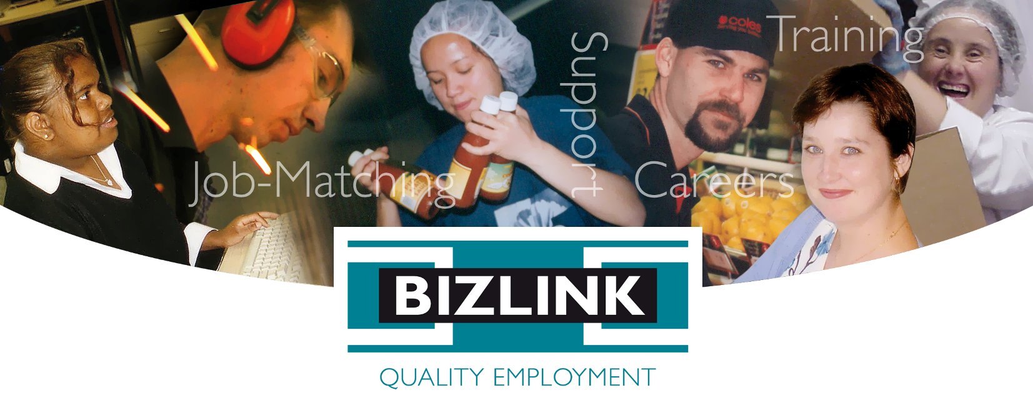

REGISTERING with BIZLINK

BIZLINK is a West Australian, not-for-profit, Disability Employment Service and is a Registered NDIS provider for School Leaver Employment Supports (SLES) and Employment Supports. BIZLINK is dedicated to securing and supporting inclusive employment in the Perth suburbs and has done so since 1992. BIZLINK has the experience and results to provide the best employment support for you.

Eligibility
Unlock your potential with personalised support. We work with people to overcome all types of barriers and achieve career goals with confidence and success:

- Learning e.g. ADHD, Dyslexia
- Literacy e.g. difficulty with reading / writing
- Medical / Mental Health / Sensory / Physical
- Communication / Attention / Social skills
- Concentration / Memory / Planning and organizing
- Motor skills / Mobility
- Anxiety / Depression

CONTACT
1300 780 789
To discuss how BIZLINK could be the BEST provider for you

BIZLINK accepts referrals from a range of sources including Centrelink, schools, other services and direct contact. We welcome calls to discuss DES or NDIS eligibility. We can assist with eligibility assessments or Centrelink can be contacted directly. BIZLINK may be able to directly register you or can provide advice on other services.

If you are interested in our NDIS programs contact ndis@bizlink.asn.au or call 1300 780 789 and ask to speak with the NDIS Manager.

Key Eligibility for Disability Employment Services (DES-ESS) are that a job seeker:

- Is working age—has completed school to the end of the year turn 17 years or meets school leaving age requirements (unless doing a school to work transition program).
- Has a current Employment Services Assessment (ESAt) or Job Capacity Assessment (JCA) - we can assist. Students may be exempt.
- Is motivated to work and/or to develop skills to become work ready.
- Can work at least 8 hours per week, or the hours required by any Centrelink payment.
- Is willing to accept BIZLINK support.
- Can travel independent from BIZLINK (following transport training if required).
- Lives in the Perth Metropolitan.

Quality Employment
BIZLINK selectively matches job seekers to fill the criteria of each job vacancy and then provides on-site training, support and advice. BIZLINK employees who work directly with clients are required to have an up-to-date Employment Screening including the Working with Children Check and NDIS Check and relevant qualifications and/or experience.

Individualized Support
BIZLINK provides individualized support to find and keep a job, which can include:
- Resumes and Job Applications
- Interview techniques
- Job matching to your interests and skills
- Accessing training and courses
- Short-term work experience/job sampling
- Transport training
- On-the-job training and Off-site support
- Employer subsidies and incentives
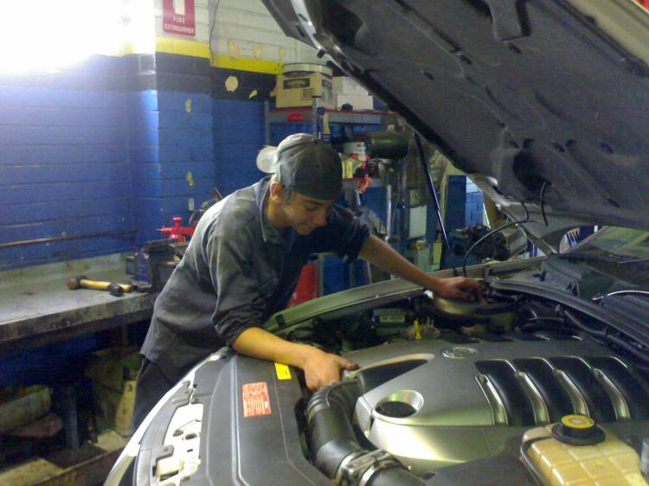
- Workplace modifications / equipment
If you have gone to Centrelink and a provider has been recommended or registered with another provider, but would prefer to register with BIZLINK, contact us.

You have a right to choose and change your provider
1300 780 789

Choose BIZLINK for:
- Convenience of offices across Perth
- Personalised job-matching
- Pre-employment training
- Individual one-to-one assistance
- Expertise in School to Work Transition, Traineeships and Apprenticeships
- Quality with NDSS, NDIS, ISO 9001 and ISO 27001 Certification
- Disability Employment Support Services (DES-ESS) and NDIS SLES / NDIS Employment Supports

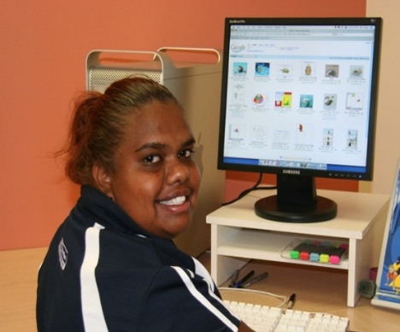

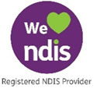
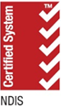
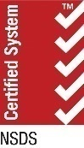
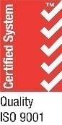
Tel: 1300 780 789
Job-matching | Training | Support | Careers | www.bizlink.asn.au

