March 2019 Volume 1

TASTE E-NEWS

First TASTE Workshop a Success

Veena, Site Manager and Les, Employment Coordinator from the BIZLINK Melville office successfully ran the first TASTE workshop for 2019. People who live in the Melville, Cockburn and surrounding suburbs participated.

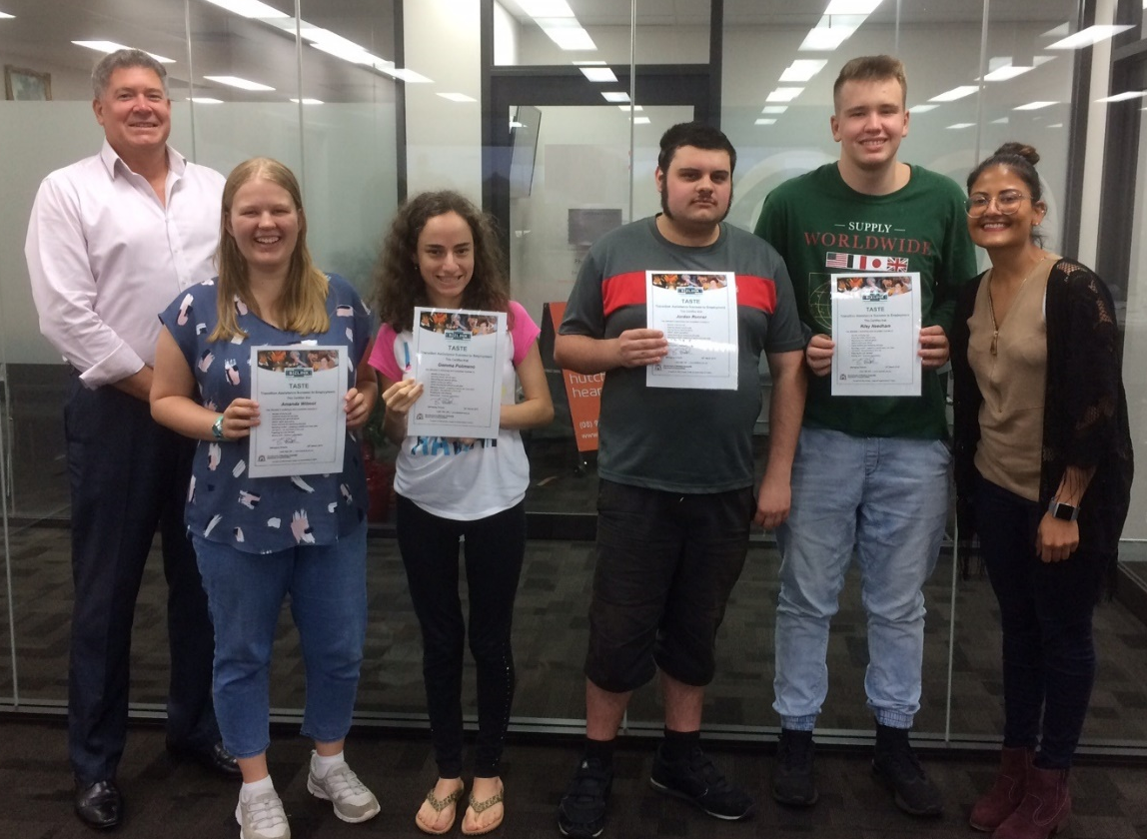
The workshop went for two half days and covered all 9 modules of the TASTE program. The modules are designed to prepare individuals with a disability for employment. The highlight of the workshop was the interview role-playing activity which everyone enjoyed the most.

Participant feedback from our inaugural workshop has helped us to modify the course and BIZLINK has set dates for workshops to be run across Perth.

This project is an NDIS Information, Linkages and Capacity Building (ILC) initiative.
For more ILC events and resources please visit www.disability.wa.gov.au/wa-ndis/wa-ndis/information-linkages-and-capacity-building/resources/

Transition Assistance Success To Employment

Upcoming TASTE Workshops

Date/Time | Location | Contact details / registration
Melville | May Workshop Series:  1-3 May 2019  Wednesday 9am to 12pm  Thursday 9am to 12pm  Friday 9am to 1pm | BIZLINK Melville Office  Suite 7, Level 1  275 Marmion Street  Melville | Registrations close Tuesday 30 April 2019. To book your place contact:  Les Faulds - 9433 2653  les@bizlink.asn.au
Joondalup | May Workshop Series:  6-8 May 2019  Monday 9am to 12.30pm  Tuesday 9am to 12.30pm  Wednesday 9am to 12.30pm | Joondalup Library  102 Boas Ave Joondalup | Registrations close Thursday 2nd May 2019. To book your place contact:  Tracey Tumata - 1300 780 789  traceyt@bizlink.asn.au
Rockingham | May Workshop Series:  14-15 May and 21-22 May 2019  Tuesday 9am to 1pm  Wednesday 9am to 1pm  Tuesday 9am to 1pm  Wednesday 9am to 1pm | BIZLINK Rockingham Office  1/1 Benjamin Way Rockingham | Registrations close Monday 13 May 2019. To book your place contact:  Layna - 6230 2236  layna@bizlink.asn.au
Midland | May Workshop Series:  14 & 16 May and 21 & 23 May 2019  Tuesday 9am to 12pm  Thursday 9am to 12pm  Tuesday 9am to 1pm  Thursday 9am to 1pm | BIZLINK Midland Office  53 The Crescent Midland | Registrations close Monday 13 May 2019. To book your place contact:  Charlie Lenzo or Liz Zidich – 6454 1859, charlie@bizlink.asn.au / liz@bizlink.asn.au
Midland | November Workshop Series  12 & 14 Nov and 19 & 21 Nov 2019  Tuesday 9am to 12pm  Thursday 9am to 12pm  Tuesday 9am to 1pm  Thursday 9am to 1pm | BIZLINK Midland Office  53 The Crescent Midland | Registrations close Monday 11 November 2019. To book your place contact:  Charlie Lenzo or Liz Zidich – 6454 1859, charlie@bizlink.asn.au / liz@bizlink.asn.au

BIZLINK and other services workshops are advertised here:

www.disability.wa.gov.au/wa-ndis/wa-ndis/information-linkages-and-capacity-building/ilc-calendar/

Choose BIZLINK
BIZLINK is a West Australian, not-for-profit, employment service. BIZLINK is dedicated to securing and supporting inclusive employment in the Perth suburbs and has done so since 1992.
Choose BIZLINK for:

- A free service
- Convenience of 7 offices across the Perth suburbs
- Personalised job-matching
- Individual one-to-one assistance
- On-site training support and advice
- Experienced Apprenticeship and Traineeship support

CONTACT
1300 780 789
To discuss how BIZLINK could be the BEST provider for you

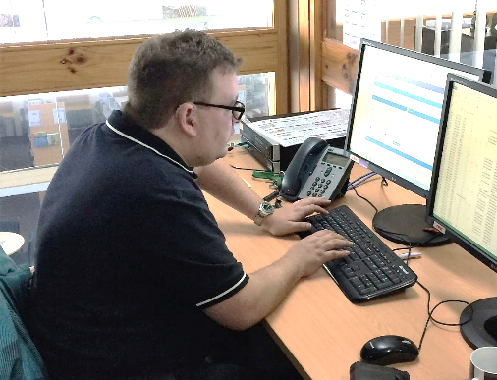
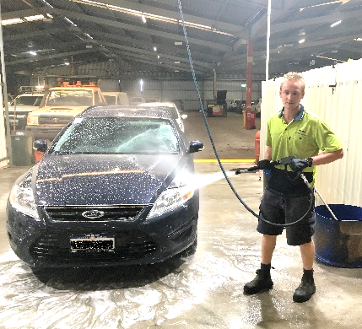

Got a Story to Share?

We love sharing client’s stories about their career and other achievements. Let your Coordinator know if you have something you would like published in BIZZYBODIES and/or posted on our Facebook page.

www.facebook.com/bizlinkqualityemployment

Getting Information
How You Need It

BIZLINK assists people with a range of abilities. Staff can read and explain this information or we can provide the information in different ways, such as in large print, another language or electronically, as needed. Please discuss with your Coordinator or contact BIZLINK.

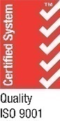
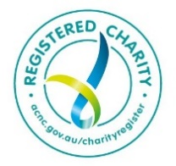
Tel: 1300 780 789 Email: bizlink@bzlink.asn.au Post: PO Box 284 Joondalup 6919 ABN: 28 473 809 505
East Perth Melville Cockburn Central Rockingham Joondalup Innaloo Midland
Job-matching | Training | Support | Careers | www.bizlink.asn.au
