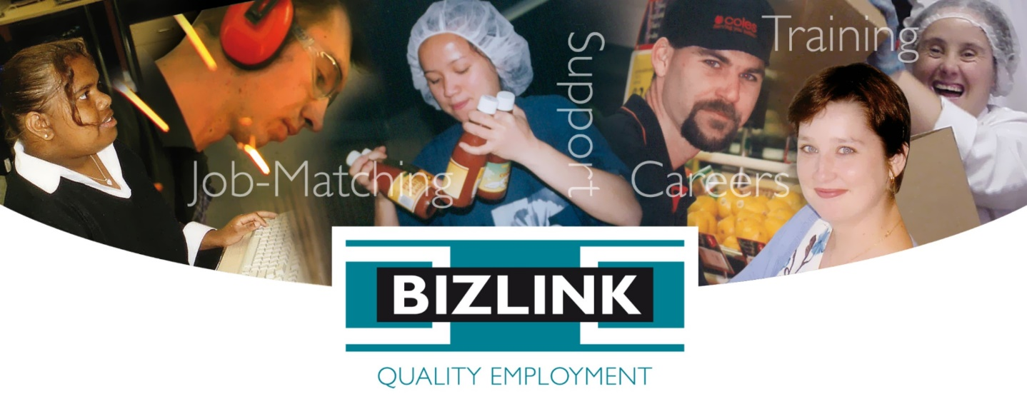

October 2019 Volume 2

## TASTE E-NEWS

**TASTE Workshops**

BIZLINK has been running TASTE workshops across all of our sites since the inaugral Melville TASTE in March 2019. The 2-3 day workshops have consisted of 9 modules that have been designed to prepare individuals with a disability for employment.

Ongoing participant feedback from our workshops has helped us to modify the modules to meet individual requirements. An important aspect of TASTE is that it is ‘co-designed’. This has allowed BIZLINK to engage with several schools and other service providers to help participants be more confident to find a job.

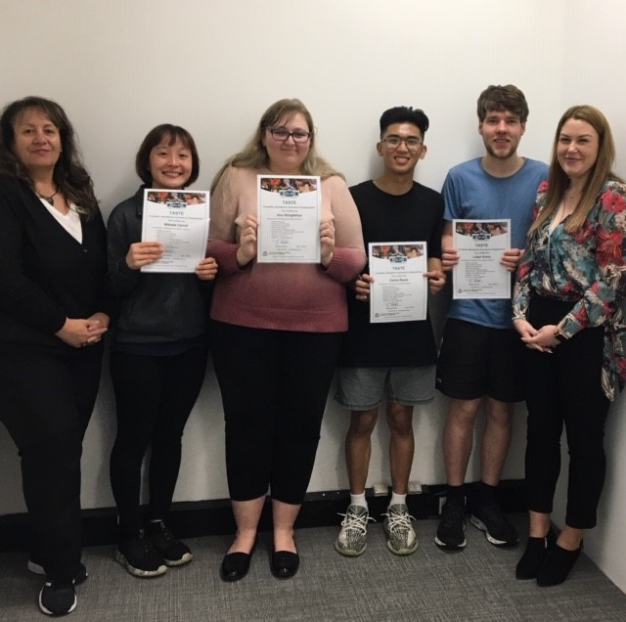

Pictured 1 Tracey & Telka with Joondalup   
TASTE participants

Participation in TASTE is leading to some amazing outcomes. Participants have achieved successful job placements, work experience and voluntary opportunities. If you have a good news story from your particpation or would like to share some feedback, please don’t hesitate to contact us:

Call 1300 780 789 or email [taste@bizlink.asn.au](mailto:taste@bizlink.asn.au) to share your story, find out more or to book a place at our next workshop.

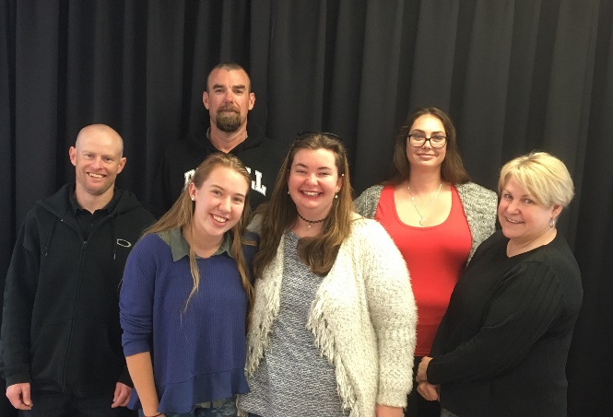

Pictured 2 Steph with Rockingham TASTE participants

## TASTE Employment Success

## Alby participated in the May 2019 Melville TASTE series and was successful in gaining employment as a school bus driver in June 2019.

Alby was recently acknowledged by BIZLINK Support Coordinator, Andy Perks. Alby received a Career Achievement Award, which recognised his humility and customer care.

Alby works as a school bus driver and was punched square in the face by a student. Alby’s reaction was not only to laugh it off but to care for the pupil’s well-being. The student has since given Alby a handmade card to apologize. Alby stated, “It’s the best thing anyone has done for him”.

Alby planned a fun day for his students, turning his school bus into a Pirate Ship. A number of students had been distressed and emotional with the punching incident so Alby thought this would be a good way to bring them all together.

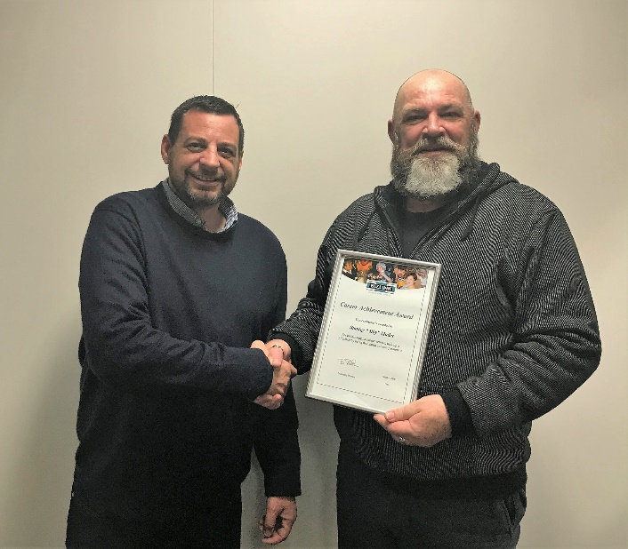

Pictured 3 Andy awarding Alby for Career Achievement

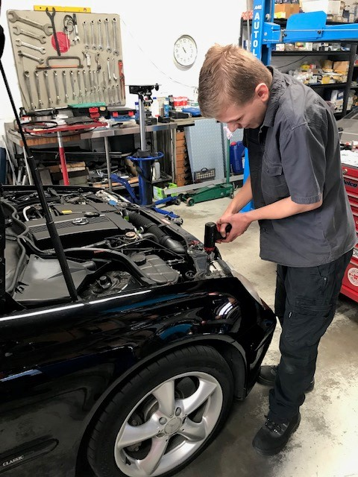

Pictured 4 Peter at Prestige Autologic

Peter is really enjoying his job at Prestige AutoLogic. After completing the Rockingham TASTE workshop in May 2019 through his school, Peter has been successful in turning his work experience into his dream job with assistance from his BIZLINK Job Search Coordinator, Tony.

As it is his first job, Peter is learning a lot. Peter has told us that his employer, is a good patient teacher who is instructing at a rate that he feels comfortable. “He allows me to work at my natural pace and complete tasks to satisfaction. It’s about the quality of work.”

Peter’s goal is to complete a mechanical apprenticeship, and he is well on his way. Peter feels that the job is well suited to his abilities and it will help him to improve his knowledge of car mechanics and better advance him towards his employment goal.

**Upcoming TASTE Workshops**

| **Date/Time** | **Location** | **Contact details / registration** |
| --- | --- | --- |
| **Midland | October/ November Workshop Series**:  22 & 24 Oct, 29 & 31 Oct, 5 & 7 Nov and 12 Nov 2019 | BIZLINK Midland Office  53 The Crescent Midland | Registrations have closed.  Enquires: Liz Zidich – 6454 1859, [liz@bizlink.asn.au](mailto:liz@bizlink.asn.au) |
| **Rockingham | December Workshop Series**:  3-4 December 2019  Tuesday 9am to 1pm  Wednesday 9am to 1pm | BIZLINK Rockingham Office  1/1 Benjamin Way Rockingham | To book your place contact:  Layna - 6230 2236  [layna@bizlink.asn.au](mailto:layna@bizlink.asn.au) |
| **Melville | February Workshop Series:**  12-14 February 2020  Wednesday 9am to 12pm  Thursday 9am to 12pm  Friday 9am to 1pm | BIZLINK Melville Office  Suite 7, Level 1  275 Marmion Street  Melville | To book your place contact:  Les Faulds - 9433 2653  [les@bizlink.asn.au](mailto:les@bizlink.asn.au) |
| **Joondalup | February Workshop Series**:  18-20 February 2020  Tuesday 9.30am to 12.30pm  Wednesday 9.30am to 12.30pm  Thursday 9.30am to 12.30pm | Joondalup Commercial Centre  87 McLarty Avenue Joondalup | To book your place contact:  Tracey Tumata - 1300 780 789  [traceyt@bizlink.asn.au](mailto:traceyt@bizlink.asn.au) |
| **Midland | March Workshop Series**  10, 17 & 24 March 2020  Tuesday 9.30am to 12.30pm  Tuesday 9.30am to 12.30pm  Tuesday 9.30 to 12.30 | BIZLINK Midland Office  53 The Crescent Midland | To book your place contact:  Liz Zidich – 6454 1859, [liz@bizlink.asn.au](mailto:liz@bizlink.asn.au) |
| **Joondalup | June Workshop Series:**  **16-18 June 2020**  Tuesday 9.30am to 12.30pm  Wednesday 9.30am to 12.30pm  Thursday 9.30am to 12.30pm | Joondalup Commercial Centre  87 McLarty Avenue Joondalup | To book your place contact:  Tracey Tumata - 1300 780 789  [traceyt@bizlink.asn.au](mailto:traceyt@bizlink.asn.au) |

BIZLINK and other services workshops are advertised here:

[www.disability.wa.gov.au/wa-ndis/wa-ndis/information-linkages-and-capacity-building/ilc-calendar/](http://www.disability.wa.gov.au/wa-ndis/wa-ndis/information-linkages-and-capacity-building/ilc-calendar/)



This project is an NDIS Information, Linkages and Capacity Building (ILC) initiative. For more ILC events and resources please visit [www.disability.wa.gov.au/wa-ndis/wa-ndis/information-linkages-and-capacity-building/resources/](http://www.disability.wa.gov.au/wa-ndis/wa-ndis/information-linkages-and-capacity-building/resources/)

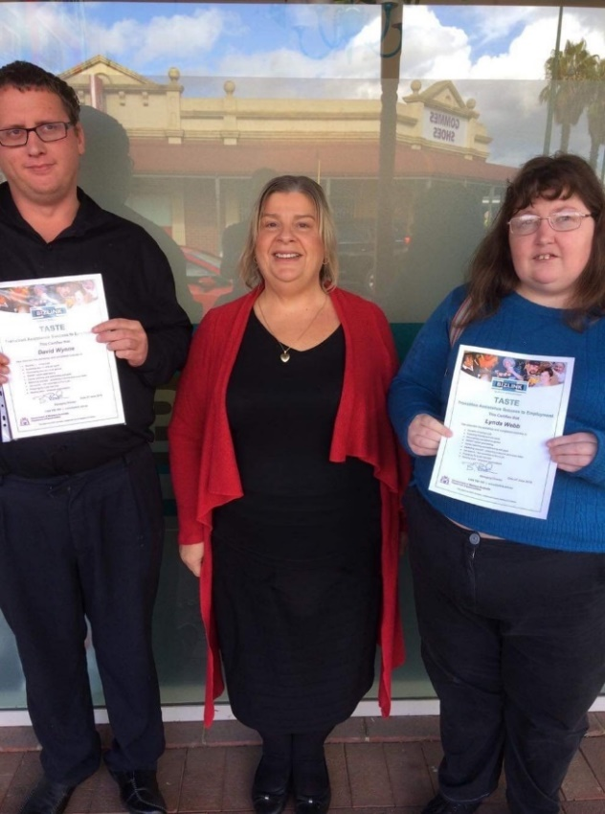

Pictured 5 Liz with Midland TASTE participants

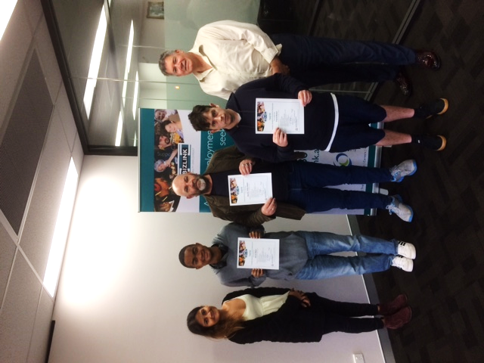

Pictured 6 Veena & Les with Melville TASTE participants

