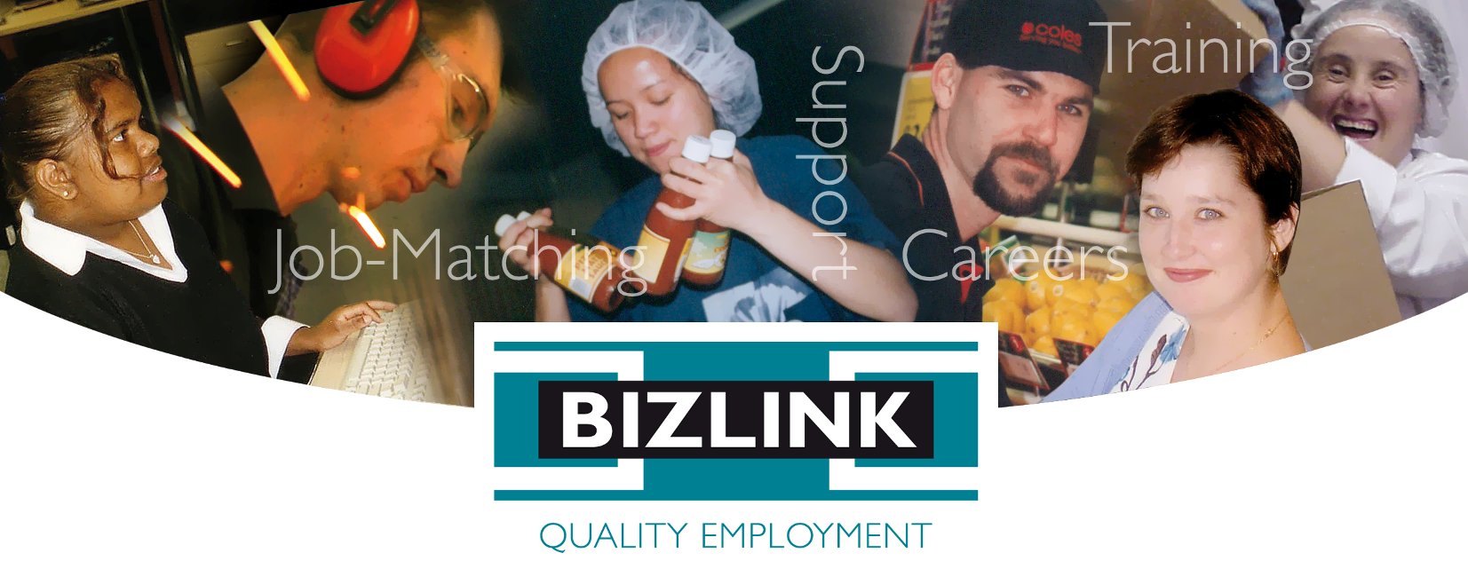
Want a TASTE of Work? Not Sure Where to Start?
BIZLINK Can Help!

Transition Assistance Success to Employment (TASTE) will equip you with the skills to prepare for, find and keep a job. If you are an unemployed person with a disability and live in the Perth Metro, you may be eligible for the BIZLINK TASTE program.

TASTE is Free thanks to funding from the Department of Communities and includes workshops that run for 2 to 4 half days. You will:

- Gain knowledge, skills and confidence to achieve your employment goals
- Explore goal setting and career choices
- Look at resumes and cover letters to market yourself to employers
- Learn how to find and apply for jobs
- Discuss employer expectations
- Develop a portfolio including your bank account, tax file number, transport needs
- Experience job tasters with our supportive employers
- Be linked to services to meet your needs and achieve your employment goals

Workshops run at a location near you
BIZLINK - 1300 780 789 - ask about TASTE

East Perth Melville Cockburn Central Rockingham Joondalup Innaloo Midland
Job-matching | Training | Support | Careers | www.bizlink.asn.au
This project is an NDIS Information, Linkages and Capacity Building (ILC) initiative.
For more ILC events and resources please visit www.disability.wa.gov.au/wa-ndis/wa-ndis/information-linkages-and-capacity-building/resources/

