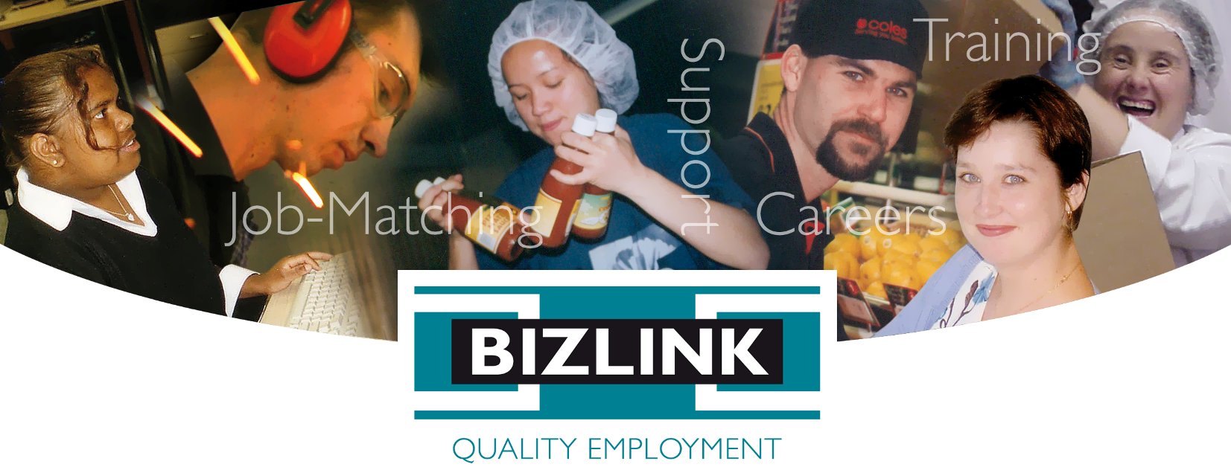
TASTE Workshop Outline

Transition Assistance Success to Employment (TASTE) will equip you with the skills to prepare for, find and keep a job. TASTE is Free thanks to funding from the Department of Communities and includes workshops that run for 2 to 4 half days, to suit participants needs.
Days / Times* | TASTE Program Outline & Key Objectives
DAY 1  9am – 12pm  INTRODUCTION | Introduction to DES, ADE & NDIS Finding and Keeping a Job  MODULE 1: Why Get a Job?
DAY 2  9am - 12pm  DISCOVER & EXPLORE | MODULE 2: Explore Industry & Job Types (+Guest Speaker)  MODULE 3: Discovering your Personal Genius  MODULE 4: SMART Career Goal Setting
DAY 3  9am– 1pm  PREPARE & PLAN | MODULE 5: Career Planning & Addressing Skills Gap  MODULE 6: Market Yourself: Preparing Resume and Cover Letters  MODULE 7: Job Search: The Essentials.  Thinking Outside the Box: The Hidden Jobs Market
DAY 4  9am - 1pm  ACTIONS & MAINTENANCE | MODULE 8: Preparing for Job Interviews  MODULE 9: Starting Work (+Guest Speaker)  Individual Career Action Plan
JOB TASTERS & ONGOING MENTORING | Days and times will vary depending on individual needs as outlined in the Individual Career Action Plan for each participant
*Days and times will change depending on group size and need
Workshops run at a location near you
BIZLINK - 1300 780 789 - ask about TASTE
East Perth Melville Cockburn Central Rockingham Joondalup Innaloo Midland
Job-matching | Training | Support | Careers | www.bizlink.asn.au
This project is an NDIS Information, Linkages and Capacity Building (ILC) initiative. For more ILC events and resources please visit www.disability.wa.gov.au/wa-ndis/wa-ndis/information-linkages-and-capacity-building/resources/

